Heaven’s light is our guide

Rajshahi University of Engineering & Technology

Mono-COLOR

Department of Materials Science & Engineering

A thesis report on

**Synthesis and Characterization of Undoped and Yttrium Doped Zinc Oxide Thin Films Obtained by Spin Coating**

**Supervised by** **Submitted by**

S.M. Nasim Rokon Maruf Ahmed  
Lecturer Roll No.: 1713028  
Dept. of Materials Science & Engineering Rahik Ibne Forman  
RUET, 6204, Bangladesh Roll No.: 1713029

**October 2023**

Heaven’s light is our guide

Rajshahi University of Engineering & Technology

Mono-COLOR

Department of Mechanical Engineering

A project & thesis report on

**Synthesis and Characterization of Yttrium Doped, and Undoped Zinc Oxide Thin Films Obtained by Spin Coating**

This report is submitted in partial fulfilment of the requirements for the degree of Bachelor of Science in Materials Science & Engineering at Rajshahi University of Engineering & Technology, Rajshahi, Bangladesh.

**Supervised by** **Submitted by**

S.M. Nasim Rokon Maruf Ahmed  
Lecturer Roll No.: 1713028  
Dept. of Materials Science & Engineering Rahik Ibne Forman  
RUET, 6204, Bangladesh Roll No.: 1713029

Heaven’s light is our guide

Rajshahi University of Engineering & Technology

Department of Materials Science & Engineering

**Certificate**

This is to certify that the work entitled **“Synthesis and Characterization of Yttrium Doped, and Undoped Zinc Oxide Thin Films Obtained by Spin Coating”** has been carried out by Maruf Ahmed, Roll: 1713028 and Rahik Ibne Forman, Roll: 1713029 in the Department of Materials Science & Engineering at Rajshahi University of Engineering & Technology under my supervision.

|  |  |
| --- | --- |
| **Supervised by**  *…………………………..* | **Signature of the External Examiner**  *…………………………………* |
| **S.M. Nasim Rokon** |  |
| Lecturer | *………………………………….* |
| Dept. of Materials Science & Engineering |
| RUET, 6204, Bangladesh | Dept. of Materials Science & EngineeringRUET, 6204, Bangladesh |
|  |  |
| **Countersigned** |  |
| *…………………….* |  |
|  |
| **Dr. Mohammad Shahed Hasan Khan Tushar** |  |
| Professor & Head,  Dept. of Materials Science & Engineering |  |
| RUET, 6204, Bangladesh |  |
|  |  |

**Acknowledgment**

All the praises and the supreme thanks belong to Allah, “Lord of All the Worlds, Most Beneficent, Ever-Merciful”.

It’s a great pleasure and privilege for the authors to present this report on **“Synthesis and Characterization of Yttrium Doped, and Undoped Zinc Oxide Thin Films Obtained by Spin Coating”**

The authors would like to express their deepest sense of gratitude to their supervisor, S.M. Nasim Rokon , Department of Materials Science & Engineering, Rajshahi University of Engineering & Technology, Rajshahi, for his encouragement and useful solutions to this work. His encouragement and motivation were certainly a matter of pride.

Special thanks to the technical officer and laboratory assistant of the Department of Materials Science & Engineering and Department of Electrical & Electronic Engineering, Rajshahi University of Engineering & Technology for the technical support needed to complete the project.

Date: October 04, 2023 Authors

Rajshahi University of Engineering & Technology, Maruf Ahmed

Rajshahi, Bangladesh. and

Rahik Ibne Forman

**Abstract**

.

The aim of this thesis is to determine the effects of Yttrium doping on the optoelectronics properties of ZnO thin films. In this work, the basic electrical and optical characteristics of ZnO thin films were studied. ZnO is a wide band gap semiconductor. In our thesis, we focused on the improvement of electrical properties by decreasing the band gap energy. Yttrium was chosen due to its compatibility of incorporation into ZnO crystal structure. Investigations were followed by several characterizations (XRD, SEM, EDS, UV-Visible Spectroscopy) to determine the changes in the electrical and optical properties. Few developments of properties were observed from the characterizations results and analysis. The crystal structure of Zno was determined as wurtzite structure, and the preferential growth was obtained along (002) direction. Crystallite sizes were changed in doped films such as 12.319 nm in 1% YZO and 18.338 nm in 3% YZO. Microstrain increased in the doped materials. Bandgap energy also changed such as 3.22 eV, 3.19 eV, 3.11 eV and 3.05 eV in undoped, 1% YZO, 3% YZO and 5% YZO thin films respectively. Nanoclusters were formed which was observed in the SEM images. The UV-Visible studies showed the enhancement in the optical transparency, and the band gap energy also decreased which is a favorable outcome for electrical conductivity. The EDX spectrum confirmed the presence of Zn, O, and Si elements in the pure ZnO and Zn, O, Y and Si in the doped film.

**Keywords**

Thin films, Spin coating, Doping, Optoelectronics properties

**List of Contents**

**Chapter Title Page No**

**Chapter 1 INTRODUCTION** 1

1.1 Overview 1

1.2 Objectives 1

1.3 Limitations 1

1.4 Applications 2

1.4.1 Transparent Conducting Oxides 2

1.4.2 Solar Cells 2

1.4.3 Gas Sensors 2

1.4.4 LEDs 3

1.4.5 Transistors 3

1.4.6 Varistors 3

**Chapter 2 LITERATURE REVIEW** 7

Literature Review 7

**Chapter 3 THEORY** 08

3.1 Semiconductors08

3.1.1 Energy Band Structure 08

3.1.2 Intrinsic and Extrinsic Semiconductors 10

3.1.3 Charge Carriers in Semiconductors 12

3.2 Transparent Conducting Oxides13

3.2.1 Properties of TCO 15

3.2.2 n-type TCO 15

3.2.3 p-type TCO 16

3.2.4 Electrical Conductivity 17

3.2.5 Optical Properties 18

3.2.6 Work function 19

3.2.7 Thermal and Chemical Stability 20

3.2.8 ZnO as TCOs 20

3.3 LED22

3.4 ZnO24

3.4.1 Crystal Structure of ZnO 24

3.4.2 Defects in ZnO 25

3.4.3 n-type ZnO 26

3.5 Thin Film Deposition Techniques27

3.5.1 Classification 28

3.5.2 Atomic Layer Deposition 30

3.5.3 Pulsed Laser Deposition 30

3.5.4 Sputtering Techniques 31

3.5.4.1 Mechanism 31

3.5.4.2 Magnetron Sputtering 32

3.5.5 Sol gel Process 32

3.5.5.1 Mechanism 32

3.5.5.2 Sol gel Coating Technique 34

3.5.5.2.1 Spin Coating 34

3.5.5.2.2 Dip Coating 35

3.5.5.2.3 Sol gel spin coating Techniques 36

3.5.5.2.4 Adv. and Disadv. of spin Coating 37

3.5.5.2.5 Adv. and Disadv. of sol gel Technique 37

3.6 Characterization Principles38

3.6.1 Structural Studies 39

3.6.1.1 XRD 39

3.6.1.2 SEM 41

3.6.2 Optical Studies 43

3.6.2.1 UV-visible Spectroscopy 44

**Chapter** **4 METHODOLOGY**  46

4.1 Film Synthesis46

4.1.1 Raw Materials 46

4.1.2 Doping Material 48

4.1.3 Other Ingredients 48

4.2 Requirements of Raw Material49

4.3 Solution Preparation50

4.3.1 Steps in Detail 50

4.4 Glass Preparation52

4.5 Spin Coating54

4.6 Drying55

4.7 Annealing55

**Chapter** **5 RESULT AND DISCUSSION** 56

5.1 XRD Analysis56

5.2 Morphological Properties59

5.2.1 SEM 60

5.2.2 EDS 60

5.3 Optical Properties61

5.3.1 UV-visible Results 61

**Chapter** **6** **CONCLUSIONS & RECOMMENDATIONS**  65

6.1 Conclusions65

6.2 Recommendations66

**REFERENCES** 68

**APPENDIX** 74

**List of Figures**

**Figure No Title Page No**

3.1 Interatomic separation for the electron energy band 13

3.2 Different potential electron band configurations 14

3.3 Band gap with the acceptor and donor level 15

3.4 The distribution function of Fermi-Dirac 17

3.5 a) In2O3 doped with Sn, b) In2O3 schematic orbital diagrams 21

3.6 resistivities of binary TCO 22

3.7 Optical transparency versus conductivity 23

3.8 Optical transparency and Seeback data 23

3.8.1 Carrier concentration, bandgap energy, and work function 25

3.9 ZnO/ Ag film/ZnO structure 27

3.10 illustration of LED mounted on TIM 29

3.11 Uncoated Cu substrate 30

3.12 wurtzite ZnO in its hexagonal unit cell 31

3.13 Crystalline structure zone model of sputtered ZnO thin films 32

3.14 Energy levels of native defects in ZnO 33

3.15 Classification of different film deposition techniques 36

3.16 Relationship between growth intensity and orientation 37

3.17 Basics of synthesis by sol gel methodology 40

3.18 A schematic of spin-coat deposition 41

3.19 A schematic of dip-coat deposition 42

3.20 Static spin coating technique 43

4.21 Dynamic spin coating technique 43

3.22 X-ray diffraction from Bragg planes 47

3.23 Photograph of X-ray diffractometer 48

**Figure No Title Page No**

3.24 SEM working principle 49

3.25 UV-Visible spectrophotometer operating mechanism 52

3.26 FTIR spectroscopy 54

4.1 Raw chemical reagents 56

4.2 Starting Material (Zinc Acetate Dehydrate) 57

4.3 Solvent and Stabilizer 58

4.4 Doping material 59

4.5 (a) Ultrasonic Cleaner (b) Hot Plate (c) Micro-pipet and (d) Glass Cutter 60

4.6 (a) Initial Solution (precursor) and (b) Solution stirring 62

4.7 Weighting Procedure 63

4.8 Solution After Mixing 64

4.9 Solution stirring for 1 hour 65

4.10 a) Glass Slide;

(b) Glass Slide After Cutting and

(c) Dipped in distilled water, ethanol and acetone 67

4.11 Spin Coater 67

4.12 Spin coating process 67

4.13 Annealing graph 69

5.1 XRD graph of pure ZnO thin film sample 72

5.2 XRD graphs of all samples 73

5.3 SEM of (a) Pure ZnO

(b) 1%Y doped ZnO, (c) 3%Y doped ZnO and

(d) 5%Y doped ZnO . 77

5.4 EDX spectrum of pure ZnO and YZO 80

5.5 Plot of (𝛼ℎ𝜐) 2 versus incident photon energy (h𝜐) 81

5.6 UV-vis absorption spectrum of Pure ZnO and YZO 84

5.7 Electrical resistivity of the yttrium-doped ZnO thin films 86

5.8 Electrical resistivity (ρ), carrier concentration (n), and mobility (µ) 87

5.5 Plot of (𝛼ℎ𝜐) 2 versus incident photon energy (h𝜐) 81

**List of Tables**

**Table No Title Page No**

1 Applications of ZnO-based semiconductors 5

3.1 Published results regarding TCO layers 18

3.2 Resistivities, Carrier Concentrations, and Dopant Content

for ZnO Films Doped with Various Impurities 22

4.1 Requirements of materials 61

5.1 XRD results for wurtzite ZnO for all examined samples 74

5.2 Lattice parameters analysis 75

5.3 Calculated values of the optical band gap Eg 83

**Abbreviations**

**YZO** Yttrium doped ZnO

**XRD** X-Ray Diffraction

**FWHM** Full width half maximum

**SEM**  Scanning electron microscopy

**EDS**  Energy dispersive spectroscopy

**FTIR** Fourier transform infrared spectroscopy

**NOMENCLATURE**

I0 Initial current flow

Y Yttrium

**Chapter 1**

**INTRODUCTION**

**1.1 Overview:**

Several works are done on the ZnO thin film. It has excellent performance in short wavelength devices because of its large excitation binding energy. These types of characteristics provide a stable excitonic emission at room temperature [1].

In our working process the thin film deposition technique is followed by sol-gel process, specifically spin coating deposition technique. The key benefit in this process is the usage of rotational velocity of the substrate, which assist to spread the film on the surface of the glass substrate. In addition, this is a lower cost process, provide a simple way of deposition, optimum level of homogeneity, and the lower processing temperature [2].

It also helps in the growth of a highly pure product, so this is used in the highly pure precursor solution with controlled molar fractions [3]. Thus, both manipulation and controlling of solid-state components and thin films are accurate by the sol-gel process [4].

The choice of Y as a dopant is primarily motivated by its close atomic radius to that of Zinc, which facilitates the Y ions insertion into ZnO lattice. Thus, recent studies have demonstrated the capability of Y as a dopant to ameliorate the electrical and optical features of ZnO, as well to decrease its native point defect densities [5-6].

It was found that the resistivity of YZO thin films was diminished by adding Y doping at different levels, and also reported that a large number of electrons were introduced after incorporating Y in the lattice of ZnO, and therefore increased the conductivity [7].

**1.2 Objectives:**

ZnO is one of the most promising candidate for opto-electronic materials, as it has wide direct band gap energy and large exciton binding energy. From the previous studies it was observed that, The results from structural characterizations clearly demonstrated that yttrium ions were successfully doped into the crystal lattice of ZnO matrix [8]. Here are some key objectives for the Yttrium doping in ZnO:

1. To improve both optical and electrical properties [8-11].
2. To decrease the native defect densities (As Y has near equal atomic radius and crystal parameters to that of ZnO) [12-13].
3. To determine the change of crystallite sizes by the Yttrium doping in ZnO.

**1.3 Limitations:**

The ZnO thin film deposition is a hard process, as it need to maintain a clean and dust-free environment, which is quite tough. The glass substrate must be cleaned perfectly and scratch free, which is quite impossible to observe in open eye. So, the whole process has uncertainty of success till the last of the process. Even after the deposition of the film of solution, it mandatory to prevent from the contact of the air, as the air molecules or dustup can distort the film. So, it is very hard to prepare and maintain a perfect thin film of ZnO. After the glass cleaning, the timing is also a factor. The times of coating and heating or drying process should be in a controlled way or the deposition won’t be uniform and perfect.

**1.4 Applications:**

ZnO is a (II–VI) compound semiconductor with a wide direct band gap of 3.37 eV and a large exciton binding energy of 60 meV at room temperature, which makes it a promising candidate for highly efficient, ultraviolet-light-emitting diodes and ultraviolet lasers. Due to its piezoelectric properties, ZnO is being explored for fabricating various pressure transducers and acoustic wave and optoacoustic devices. ZnO is also one of the promising materials for applications in transparent conductors, thin-film transistors, varistors, catalysts, gas sensors and solar cells. When the ZnO is doped with external or foreign dopants, the range of applications of these doped ZnO is extended for the enhanced characteristics and modifications of several parameters of properties [25].

**1.4.1 Transparent Conducting Oxides:**

There are several good combinations of properties are observed in Zinc Oxide semiconductor materials, such as optical transparency at visible wavelengths, have satisfactory values of band-gap (direct and wide bandgap at room temperature). These semiconductors also show large exciton binding energy (about 60 Mev at room temperature). These properties make it suitable for many optoelectronics applications [14]. For TCO materials, both electrical conductivity and optical transparency should be properly maintained by perfect doping. Some of the materials like B-, Al-, Ga-, In-, and F- has already shown good properties for TCO (Low resistivity and high optical transparency) [15-17].

**1.4.2 Solar Cells:**

As the TCO materials are used by ZnO based semiconductors. The ZnO always show n-type conductivity due its off- stoichiometry. For this reason, it is imposed native defects, like oxygen vacancies (VO) and zinc interstitials (Zni). Thes defects create donor states within the forbidden band gap. But it is necessary to increase more for some specific purposes without the degradation of optical transparency, which can be achieved by dopants. In this case, group (iii) are more efficient as dopants such as Al, B etc. [18].

**1.4.3 Gas Sensors:**

Gas sensors based on various metal oxide semiconductors (MOS), such as SnO2, ZnO, TiO2, WO3, In2O3 , copper oxides, MoO3, Nb2O5 and so on, have been extensively studied due to their significant resistance change upon exposure to a trace concentration of toxic or flammable gas. Among these MOS, ZnO is considered as one of the most promising gas sensing materials for its high chemical and thermal stability, low cost, fast response and flexibility in synthesis [19].

**1.4.4 LEDs:**

Zinc oxide (ZnO) is an attractive candidate for UV light emission since it is an environmentally friendly material which can be grown at low temperatures on cheap transparent substrates and has both a direct wide band gap of 3.3 eV and a very large exciton binding energy of 60 meV and important for robust light emission [20,21].

ZnO and related semiconductors are alternatives to GaN based compounds for fabrication of UV/blue light emitting diodes (LEDs). Progress in development of ZnO LEDs has been disappointing due to the difficulty of achieving robust p-type doping and the low crystal quality of heterojunctions and quantum wells [22].

**1.4.5 Transistors:**

The potential for flexible, lightweight, mechanically robust electronics for displays and other devices on plastic substrates has motivated considerable research on new materials and improved processes for fabricating thin film transistors (TFTs).

A stable inorganic semiconductor compatible with temperature sensitive substrates, and with electronic properties equivalent to amorphous Si would enable electronics on a variety of flexible substrates. It is contended that a ZnO semiconductor can meet those requirements [23].

**1.4.6 Varistors:**

ZnO powders are very important materials due to many interesting properties inherent in this material, such as dielectric, piezoelectric, pyroelectric, semiconducting etc. Moreover, ZnO ceramics containing several metal oxides, such as Cr2O3, Bi2O3, Sb2O3, Co3O4, MnO2 etc., show highly nonlinear current-voltage characteristics which enables them to be used as protection devices against voltage surges and voltage transients. The varistor effects take place at the grain boundaries within the ceramics and numerous theories have been developed to explain the effect. It is necessary to have homogeneous distribution of dopants and the correct oxygen concentration to form good varistor ceramics [24].There are vast applications in the thin film technology, which can be deposited from different phases like vapor, liquid, gas or solid phase. Here, some applications are given below [26]-

Applications of Thin Films

|  |  |
| --- | --- |
| **Engineering and processing** | Protective layers and low friction coatings to reduce wear, corrosion and erosion; high temperature corrosion; surface passivation; decorative coatings; catalytic coatings |
| **Optoelectronics** | Photodetectors; liquid crystal display (LCD); TFT; optical memories; light amplification by stimulated emission of radiation (laser); LED |
| **Optics** | Integrated optics; anti-reflex and high reflecting coatings (laser mirrors, interference filters, mirrors); beam splitter; thin film polarizer. |
| **Electronics** | Integrated optics; anti-reflex and high reflecting coatings (laser mirrors, interference filters, mirrors); beam splitter; thin film polarizer. |
| **Cryotechnics** | Superconducting quantum interference devices (SQUIDS); superconducting thin films; switches; memories |
| **Optoelectronics** | Gas sensor; biosensors |

**Table 1.**Applications of ZnO-based semiconductors

**Chapter 2**

**LITERATURE REVIEW**

In 2005, R. Kaur et al. delved into the synthesis and characterization of yttrium-doped zinc oxide (YZO) films, produced through the sol-gel method and deposited using dip coating. The investigation focuses on films of various thicknesses, exploring the microstructural, electrical, and optical properties following post heat treatment. This study reveals the impact of annealing temperature and film thickness on the microstructure, crystallographic orientation, and overall quality of the films. Notably, the (002) preferential growth shifts to (101) with increasing film thickness, leading to the formation of natively textured films. The review sheds light on the intricacies of film properties, offering insights into the optimization of YZO films for specific applications [6].

In 2006, Qingjiang Yu et al. provided a thorough examination of transparent and conductive ZnO thin films doped with yttrium, fabricated through the sol–gel method. The films, prepared using zinc acetate and yttrium chloride as cations sources, 2-methoxyethanol as a solvent, and mono-ethanolamine (MEA) as a sol stabilizer, are deposited on silica glass substrates by dip-coating. The study explores the influence of yttrium concentration, heating treatment, and annealing in a reducing atmosphere on the structural, morphological, electrical, and optical properties of the ZnO thin films [90].

In 2010, Jinghai Yang et al. explored the synthesis and characterization of yttrium-doped zinc oxide (Zn1−xYxO, x = 0, 0.03, 0.05) nanoparticles via the sol–gel technique. Investigating the impact of yttrium doping concentration on the structures, morphologies, and optical properties, this study sheds light on the successful incorporation of yttrium ions into the ZnO crystal lattice. The detailed examination of structural characterizations reveals distinct optical properties, including a UV emission at ∼383 nm and a broad deep-level emission with two Gauss peaks at 539 nm (P1) and 598 nm (P2). He observed optical changes with varying yttrium doping concentrations, providing a nuanced understanding of the unique optical behavior of yttrium-doped ZnO nanoparticles [8].

In 2012, Yogamalar et al. described the hydrothermal synthesis and absorption properties of cubic-shaped zinc oxide (ZnO) nanostructures doped with varying amounts of yttrium (Y) metal cations (0 to 15 at.%). The structural and optical properties of the chemically synthesized pure and Y-doped ZnO powders are investigated using a range of techniques, including powder X-ray diffraction (XRD), field emission scanning electron spectroscopy (FESEM), transmission electron microscopy (TEM), ultraviolet-visible (UV-vis) absorbance, photoluminescence (PL), and Fourier-transform infrared spectroscopy (FT-IR). This study revealed the complex relationship between dopant concentration and ZnO lattice behavior, emphasizing the impact on structural stability, optical bandgap energy, vibrational modes, and luminescence characteristics [95].

In 2012, Necmettin Kılınç et al. described the deposition and characterization of yttrium (Y)-doped zinc oxide (ZnO) thin films with Y concentrations of 1 at.%, 5 at.%, and 10 at%. The films were deposited on glass substrates using the sol–gel dip coating method. A detailed analysis of the electrical properties of the films across a range of temperatures reveals insights into the dominant conduction mechanisms, with a focus on thermally activated band conduction, Mott’s variable range hopping (VRH), and correlated barrier hopping (CBH) models. Additionally, this study investigates the NO2 sensing properties of the films, demonstrating high sensitivity and a notable response for 1 at.% Y-doped ZnO film at 200 °C [96].

In 2013, Qingjiang Yu et al. provided a detailed analysis of the structural, electrical, and optical properties of yttrium-doped zinc oxide (YZO) thin films deposited on silica glass substrates via the sol–gel method. This investigation systematically explores the influence of yttrium doping on the crystallographic orientation, electrical resistivity, and photoluminescence characteristics of the thin films. This study emphasizes the impact of annealing conditions in a reducing atmosphere on the electrical properties and highlights the absence of a specific green emission in the yttrium-doped films, presenting a nuanced understanding of the role of yttrium in modulating the properties of ZnO thin films.

In 2014, Sungeun Heo et al. showed that the sol-gel synthesis method has emerged as a versatile approach for the fabrication of thin films with tailored properties. In particular, the incorporation of yttrium (Y) dopants into zinc oxide (ZnO) thin films has been a subject of increasing interest due to its significant impact on various physical properties. He provided an overview of recent advancements in the sol-gel synthesis of Y-doped ZnO (YZO) thin films and their implications for surface, structural, optical, and electrical properties in this work [89].

In 2015, M. Thirumoorthi et al. examined the successful deposition of both undoped and yttrium (Y)-doped zinc oxide (ZnO) thin films using the sol–gel spin coating method. With varying Y concentrations, this study provides a detailed analysis of the structural, morphological, optical, and electrical properties of the films. This investigation, utilizing techniques such as X-ray diffraction (XRD), scanning electron microscopy (SEM), energy-dispersive X-ray spectroscopy (EDX), optical transmittance, photoluminescence (PL), Fourier-transform infrared spectroscopy (FTIR), and Hall measurements, offers insights into the crystalline structure, surface morphology, elemental composition, optical transparency, bandgap variations, emission shifts, chemical bonding, and conductivity of the films [94].

In 2015, Parmod Kumar et al. investigated the influence of yttrium (Y) doping concentration (1–5%) on the structural, morphological, and optical properties of sol–gel synthesized Zn1−xYxO samples. This study reveals a critical transition point at x≥0.03 where phase segregation of Y2O3 occurs, leading to a departure from the pure ZnO wurtzite structure. X-ray diffraction patterns, supported by scanning electron microscopy, photoluminescence, and Raman spectroscopy, elucidate the impact of differing charge states, ionic radii, and coordination numbers of host lattice and dopant ions on the observed phase segregation phenomena [93].

In 2015, Sanjeev Kumar Sharma et al. explored the synthesis and characterization of self-assembled 3D flower-like yttrium-doped zinc oxide (YZO) microstructures composed of nanorods. Prepared through hydrothermal-precipitation, these YZO nanoflowers are subjected to comprehensive morphological, structural, and compositional characterizations. This study confirms a well-crystallized wurtzite hexagonal phase through various techniques, including X-ray photoelectron spectroscopy (XPS) of YZO nanopowder, which reveals distinct yttrium 3d core level spectra. Investigating the antibacterial activity of YZO nanoflowers against both gram-positive and gram-negative microorganisms, this study observes enhanced antibacterial properties attributed to the incorporation of yttrium (Y: 2 at.%). He focused on the potential of YZO nanocomposites as effective antibacterial agents with applications in infection control and highlights their fast antibacterial activity as a crucial attribute in hindering the re-emergence of infections [92].

In 2015, Narinder Kaur et al. investigated about the stress relaxation dynamics and its profound influence on the bandgap modulation of Yttrium-doped Zinc Oxide (YZO) thin films. The study, which involves the deposition of YZO thin films on quartz glass via spin coating followed by vacuum annealing, scrutinizes the preferred (002) orientation observed in all annealed YZO films. Photoluminescence (PL) spectroscopy emerges as a powerful tool, providing direct evidence of bandgap shifts linked to stress relief phenomena during thermal annealing. The study establishes a nuanced relationship between the annealing temperature, stress relaxation, and the resultant alterations in the bandgap of YZO thin films [91].

In 2018, O. Bazta et al. examined recent developments in the deposition of highly transparent, n-type zinc oxide (ZnO) thin films on glass substrates using spray pyrolysis processing. He focused on the simultaneous incorporation of yttrium (Y) dopants at varying concentrations (0, 2, 5, 7 at.%) to explore their impact on the structural, morphological, and optical properties of ZnO:Y thin films. The investigation aimed to elucidate the potential of these films for optoelectronic applications. Characterization techniques, including X-ray diffraction, field-emission scanning electron microscopy (FESEM), UV-visible absorbance measurements, and photoluminescence (PL) and cathodoluminescence (CL) spectroscopy, are employed to unveil the intricate details of the synthesized thin films [73].

**Chapter 3**

**THEORY**

Over the past 30 years, there has been a significant advancement in thin film deposition technology. The demand for innovative goods and technologies in the electronics and optical industries was the main driver of this development. Without the creation of novel thin film deposition techniques, enhanced film properties, and superior film quality, the rapid advancement of solid-state electronic devices would not have been conceivable. Thin film deposition technology is still evolving quickly, which will eventually result in progressively more complicated and sophisticated electronic gadgets.

**3.1 Semiconductors:**

Semiconductor materials can be classified into two primary types based on their electrical conductivities: elemental semiconductors, which are made of a single element like silicon, and compound semiconductors, which are made of two or more elements like zinc oxide [27]. A semiconductor's electrical conductivity can be altered by adding impurities, changing the temperature and optical excitation intensity, or both. Since these materials' electrical properties may be adjusted to meet the requirements of a given application, they can be employed in a variety of settings. Solar cells, transistors, and diodes are some common semiconductor uses.

**3.1.1 Energy Band Structure:**

An isolated atom has a number of distinct energy levels, some of which are occupied by electrons. Valence electrons are found in energy levels that are either fully or partially filled. The electron energy levels are no longer distinct in solids because of the high amounts of atoms (about Avogadro's number 1023). A periodic potential results from the many atoms that are bound together. What is known as a nearly-free electron can be used to imitate the interaction between a single electron and other electrons. However, in solids where the atoms stay in close proximity to one another, the electrons and nuclei of nearby atoms act upon or disturb the electrons. Due to this influence, each discrete atomic state may divide into a number of closely spaced electron states in the solid, forming what is known as an electron energy band [28]. The outermost electron shells are the first to be disturbed as the atoms combine, hence they are where splitting starts. The magnitude of splitting depends on interatomic spacing.

The energy levels are separate within each band, yet the distance between adjacent states is incredibly small. The electron subshells closest to the nucleus may not form bands at the equilibrium spacing, as seen in Figure 3.1 (b). As seen in the image, gaps may also exist between adjacent bands; generally, the energies within these band gaps are unavailable for electron occupation. Figure 3.1 (a) illustrates the traditional method of displaying electron band structures in solids.

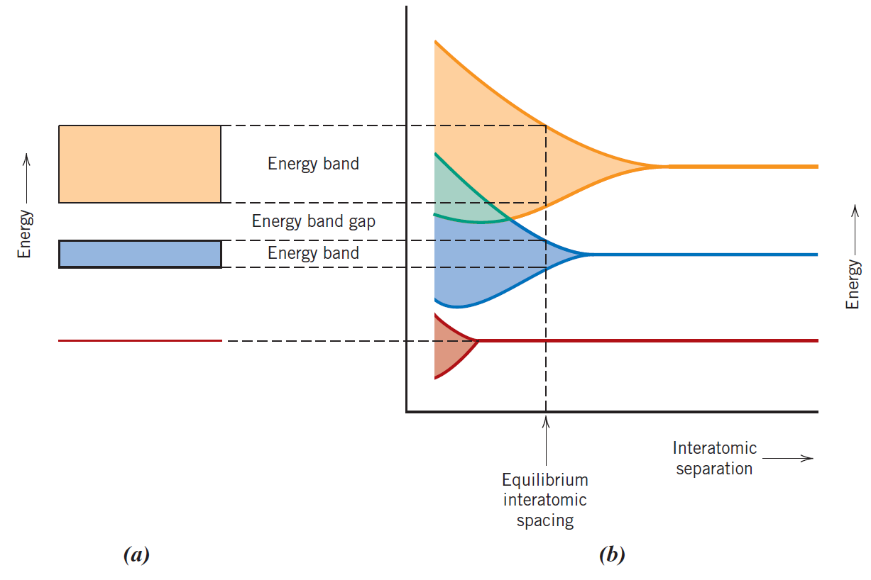

**Figure 3.1:** (a) The typical illustration of an equilibrium interatomic separation for the electron energy band structure in a solid substance. (b) Electron energy vs interatomic distance for a collection of atoms, showing the formation of the energy band structure at the equilibrium separation in (a). Reproduced from ref.[28].

The configuration of the outermost electron bands and how they are filled with electrons determine a solid's electrical characteristics, which are a result of this arrangement. In order to achieve electrical conductivity, electrons from the valence band (VB) must be stimulated into the conduction band, where they may travel in an electric field together with the holes in the valence band (VB). The size of this gap separates insulators from semiconductors and metals from semiconductors. At 0 K, four different kinds of band topologies are conceivable. One of the outermost bands in the first (Figure 3.2 a) is only partly filled with electrons. The Fermi energy, abbreviated Ef, is the energy associated with the maximum filled state at absolute zero. Some metals, especially those with a single s valence electron (like copper), are representative of this energy band structure. Each copper atom possesses one 4s electron, however the 4s band may hold up to 2N electrons in a solid made of N atoms. This means that just half of the available electron locations in the 4s band are occupied. There is an overlap between an empty band and a full band in the second band structure, which is also present in metals (Figure 3.2 b). This is the band structure of magnesium. All semiconductors are insulators at zero Kelvin. The major distinction between semiconductors and insulators is that semiconductors have lower band gaps than insulators, which permits electrons in the valence band to be driven to the conduction band when temperature is raised. Figure (3.2 c, d) illustrates that for insulators, the gap between the two bands is too wide for excitation under typical conditions.

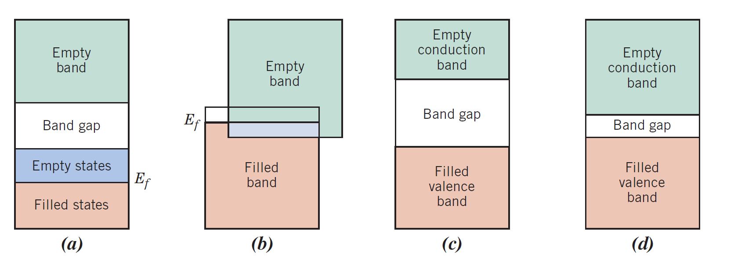

Figure 3.2: Different potential electron band configurations in materials at zero degrees Celsius. (a) Regarding metals like copper (b) Regarding metals like magnesium (c) Insulators and (d) Semiconductors. Reproduced from ref. [28].

**3.1.2 Intrinsic and Extrinsic Semiconductors:**

An intrinsic semiconductor is a pure semiconductor that has no impurities, dislocations, or other flaws. Since creating such a crystal is very impossible, it can only exist in theory. There are no electrons in CB at 0K because an intrinsic semiconductor lacks donors and acceptors. When covalent bonds are broken at higher temperatures, an electron-hole pair (EHP) is created when an electron is excited to CB and a hole (or missing electron) is left in VB. Therefore, in an intrinsic material, the number of electrons in CB (n) must be equal to the number of holes in VB (p), i.e. n = p = ni. (the quantity of intrinsic charge carriers, ni.)

Extrinsic semiconductors are those that have impurities or lattice flaws in them. By doping the material, the quantity of charge carriers can be customized for a particular application. Doping something is adding contaminants as acceptors or donors. Atoms with more valence electrons than the semiconductor material are known as donors.

The extra electrons can be used as conduction electrons by the semiconductor by being donated to it. On the other hand, acceptors are atoms that have fewer valence electrons and will so accept electrons from the crystal and thereby contribute holes. When donor doping is used, the amount of added impurities is typically high and the amount of electrons is so great that the amount of holes can be ignored. It's known as n-type doping.

When a p-type semiconductor is doped with a lot of acceptors, the electron count can be disregarded. As seen in Figure 3.3 (a), donors and acceptors have different energy levels that are referred to as donor- and acceptor levels, respectively. A donor level is referred to as a shallow donor if its energy is close to the conduction band, meaning that just a little amount of energy is required to excite the donor electrons to the conduction band. Deep donors are those whose donor level is closer to the band gap's center. Acceptor levels operate similarly, but in relation to the valence band.

In VB, electrons are quickly stimulated to these states, leaving holes in their wake. No semiconductor, regardless of how severely doped, has any electrons in the conduction band at absolute zero. For an n-type semiconductor, the donor atoms are ionized as the temperature rises, which causes the donor electrons to be stimulated to the conduction band (the ionization portion of Figure 3.3 b). All of the donor electrons are excited to CB as a result of further temperature rise, and the increase in the number of electrons excited to CB is zero (the extrinsic area of Figure 3.3 b).

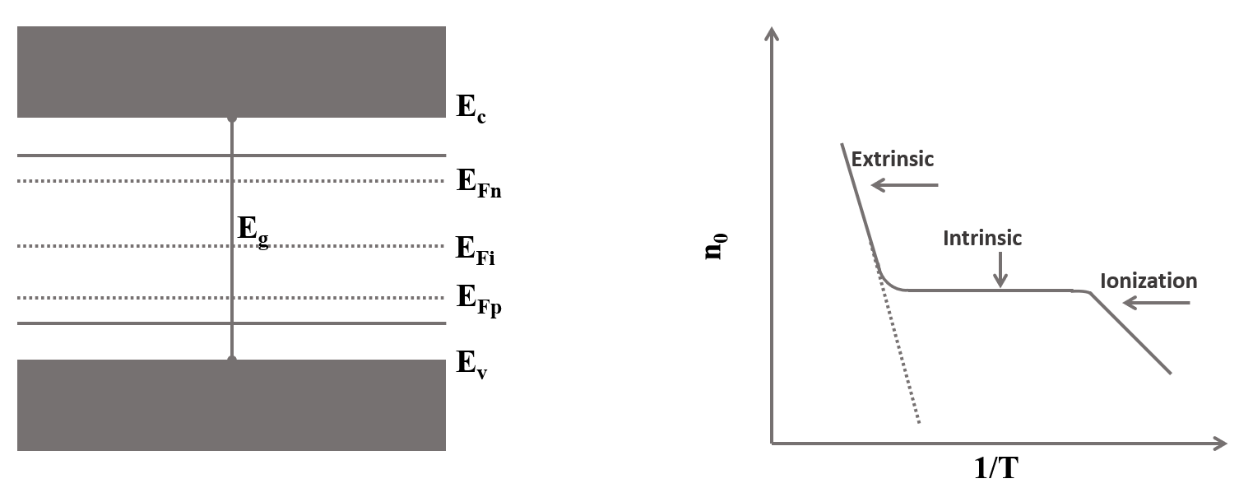

**Figure 3.3:** Band gap with the acceptor level, Ea, close to the valence band, and the donor level, Ed, close to the conduction band (a). Additionally, Figure (a) displays the Fermi levels for intrinsic semiconductors (EFi) and n- and p-type semiconductors (EFn and EFp), respectively. The electron concentration in CB is depicted as a function of temperature in Figure (b), along with the dominant mechanisms. The identical function for an intrinsic semiconductor is shown by the dashed line. reproduced using reference [28].

The intrinsic region of Figure (3.3 b) represents the point at which the temperature is high enough to excite electrons from the valence band to the conduction band. The same is true for p-type semiconductors, but at very low temperatures, electrons from the valence band are stimulated to the acceptor levels, leaving holes behind.

**3.1.3 Charge carriers in semiconductors:**

There are various factors that affect the number of electrons in the conduction band. The likelihood that an electron will occupy an energy state E at absolute zero temperature T is given by the Fermi Dirac distribution function;

**f(E) = $\frac{1}{1+e^{(E-Ef)/KT}}$… … … … … (3.1)**

Nevertheless, the probability of locating an energy state with a hole in it is equal to the probability that an electron isn't present in it;

1. **f(E) =1 - $\frac{1}{1+e^{(E-Ef)/KT}}$… … … … … (3.2)**

The semiconductor's Fermi level is denoted by the symbol Ef, whereas T represents the temperature and k is the Boltzmann constant. At absolute zero, a semiconductor's Fermi level marks the boundary between its occupied and unoccupied states.

The Fermi level for intrinsic semiconductors is located in the center of the band gap, but for extrinsic semiconductors (n-type doping and p-type doping, respectively), the Fermi level is located closer to the conduction- and valence band.

Figure 3.4 displays the distribution function from equation (3.1).



Fig 3.4: The distribution function of Fermi-Dirac. The distribution at 0 K is shown by the black line and represents a step-function at the Fermi energy, whereas the distributions are more smeared out for temperatures T1 and T2, which are higher than absolute zero. Reproduced from ref. [29]

Regardless of temperature, 50% of an energy state E = EF is occupied. The electron concentration in CB and the hole concentration in VB can be determined by looking at the likelihood that the energy state E = EC will be occupied. Equation (3.2) states that the probability of finding a hole becomes extremely small when the Fermi-Dirac distribution is close to one at low energies. Therefore, for energies below the top edge of VB, the hole concentration falls off quickly.

**3.2 Transparent Conducting Oxides:**

Electrically conductive materials called transparent conducting oxides (TCOs) have a similarly low level of light absorption. They are frequently made using thin-film processes and employed in opto-electrical devices such solar cells, displays, opto-electrical interfaces, and circuitry. While silicon and compound semiconductors are wavelength dependent optical resistors (producing mobile electrons), they are dopant dependent electrical conductors. Glass fibers are essentially lossless light conductors but electrical insulators. Both of these qualities can be found in transparent conducting oxides, a very flexible intermediate state. They can have conductivities that range from insulating to semiconducting to conducting, and their transparency can be altered. Numerous power-saving opto-electrical circuitries and technological applications are made possible by their ability to be created as n-type and p-type conductors [30].

Transparent conducting oxides (TCOs), which are an essential component in practically all thin-film photovoltaic devices due to their dual properties of optical transparency and electrical conductivity. TCOs typically rely on a small class of metal oxide semiconductors, such as In2O3, ZnO, and SnO2, which are transparent because of their wide band gaps and can withstand extremely high levels of electrical doping to provide conductivities of at least 1000 S/cm [31]. TCOs are made up of a class of substances known as "conjugate property materials," in which one characteristic—in this case, conductivity—is closely correlated with another, notably the extinction coefficient [32].

In this sense, it may be said that highly conductive materials like metals won't typically transmit visible light, whilst extremely transparent media like oxide glasses act as insulators. Understanding the fundamental material structure/property relationships that control these properties is difficult to do in order to decouple them and produce materials that are optically transparent while also being electrically conductive. There have been reports of materials being created with these qualities using a variety of phenomenological methodologies based on clear-cut physical principles.

By fundamentally comprehending the microscopic basis of the conductivity process in order to grasp the impact of chemical structure, bonding, and film shape on charge transport, more recent research push the boundaries of the earlier work. A transparent electrode with TCO is necessary for the majority of optoelectronic devices, notably those with flat panel displays. Although most transparent electrode applications have used tin-doped indium oxide (often known as indium-tin oxide, or ITO) thin films produced using magnetron sputtering, there are several reports on various TCO's as well as deposition techniques [33]. Because indium, the primary component of ITO, is expensive and in short supply, it may be challenging to maintain a steady supply of ITO for the rapidly developing market for optoelectronic devices. Thin-film transparent electrodes with unique features are further needed due to current advancements in optoelectronic devices. These issues are the major focus of recent research on materials and manufacturing processes for TCOs. For instance, several research teams across the globe are focusing on the modification of zinc oxide (ZnO) as a less expensive alternative to ITO [34].

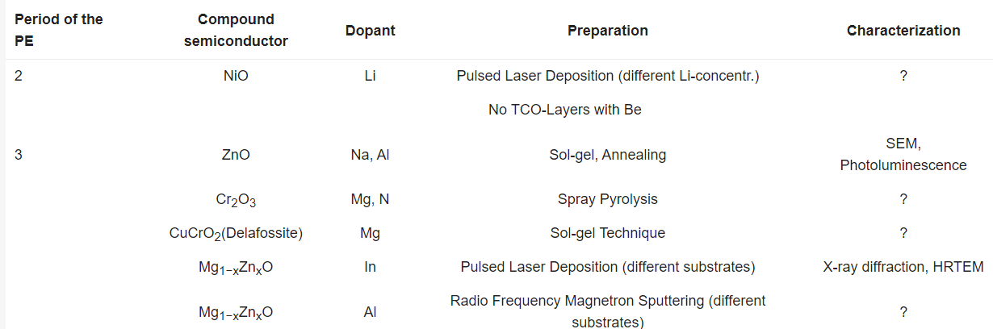

**Table 3.1.**Published results regarding transparent conducting oxide (TCO)-layers, containing metallic elements e.g., from the 2nd and 3rd period of the periodic table of the elements (PE, excluding aluminum) [30].

The oxides of tin, indium, and zinc (A = tin, indium, and zinc) exhibit exceptionally high optical properties. Indium tin oxide (ITO) and the doping of zinc oxide with less than 5% aluminum (ZnO:Al) are two examples of materials that are well recognized. Their various chemical structures and physical traits were investigated using a range of preparation and characterization techniques. We'll speak briefly about these now [30].

**3.2.1 Properties of TCO:**

TCOs are distinctive materials with optical transparency (band gaps > 3.1 eV) and electrical conductivity (carrier concentration of at least 1019cm-3). Visible light photons are prevented from excitably transferring electrons from the valence band (VB) to the conduction band (CB) by a band gap greater than 3.1 eV. By introducing defects—either inherent or extrinsic—into the system, these transparent materials are subsequently turned electrically conductive. Depending on the imperfections and the material's type of conduction, TCOs can be categorized as n-type or p-type.

In the case of p-type conduction, these defects generate split off acceptor (unoccupied) levels above the valence band maximum (VBM) and donor (occupied) levels below the conduction band minimum (CBM). ZnO based TCO films have been created using a variety of techniques, each of which has advantages and disadvantages of its own.

The thickness, substrate, growth temperature, dopant, and their composition will all have a significant impact on the structural, electrical, and optical characteristics of the films, even if they are made using the same process. The future of ZnO based TCO films will thus depend on our ability to optimize the manufacture of high-quality doped zinc oxide thin films at a reasonable price.

**3.2.2 n-type TCO:**

N-type semiconductors made of metal oxides have been the subject of the majority of research into the development of extremely transparent and conductive thin films. Historically, chemical and physical deposition techniques were used to create transparent conducting oxide (TCO) thin films made of binary compounds like SnO2 and In2O3. Indium tin oxide, or ITO, and impurity-doped SnO2 (Sb- or F-doped SnO2, for example, SnO2:Sb or SnO2:F) films are now in use. Prior to 1980, ternary compounds including Cd2SnO4, CdSnO3, and CdIn2O4 were also produced, but their TCO films have not yet been extensively employed. Other TCO materials have been developed as alternatives in order to achieve lower resistivities than those of TCO films such ITO and SnO2 doped with impurities. Impurity-doped ZnO, a cheap and plentiful binary compound material, was created in the 1980s.

To create transparent conducting films with resistivities lower than ITO and with qualities suited for particular applications, new n-type TCO material development is required. Despite the fact that new TCO materials have not yet been reported to exhibit resistivities lower than in ITO films, multicomponent oxides that have recently been produced as TCO materials are suited for particular applications. By modifying the chemical composition, it is possible to change the electrical, optical, chemical, and physical characteristics of transparent conducting multicomponent oxide films, including bandgap energy and work function [35].

**3.2.3 p-type TCO:**

Transparent conducting oxides are a special family of materials that combine optical transparency with electrical conductivity in a single substance. They are required for a variety of products, including transparent electronics, flat panel displays, touch screens, light emitting diodes, solar cells, and flat panel displays. The majority of TCOs used in industry are n-type materials, such Sn-doped In2O3, Al-doped ZnO, and F-doped SnO2. The creation of effective p-type TCOs, however, continues to be a significant obstacle. The difficulty in adding shallow acceptors and large hole effective masses is assumed to be caused by the confined character of the O 2p derived valence band. To solve this issue, Hosono and colleagues (1997 Nature 389 939) suggested the idea of 'chemical manipulation of the valence band' by hybridizing O 2p orbitals with close-shell Cu 3d10 orbitals. With a thorough grasp of the underlying materials physics, this discovery has spurred a great deal of interest in creating p-TCO materials [36].

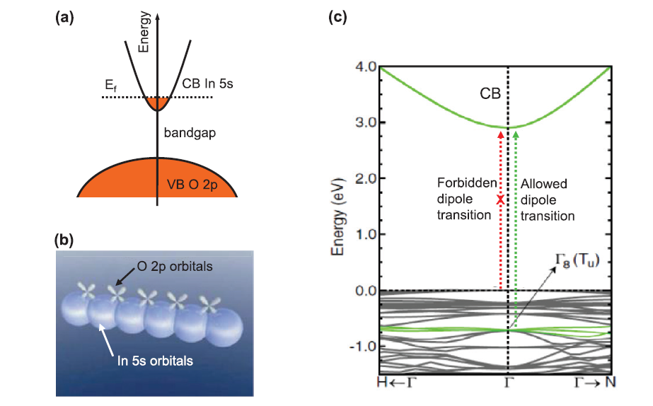

**Figure 3.5:** (a) In2O3 doped with Sn, with a schematic electrical structure illustrating the conduction band (CB) produced from In 5s and the valence band (VB) derived from O 2p; (b) In2O3 schematic orbital diagrams; Large spheres represent In 5s orbitals, displaying direct overlap between nearby s orbitals; oxygen 2p orbitals contribute little to the picture. (c) Density functional theory (DFT) calculated band structure of In2O3 [36].

**3.2.4 Electrical conductivity:**

Due to doping by oxygen vacancies or extrinsic dopants, TCOs are wide band gap (Eg) semiconducting oxides with conductivities in the range of 102 to 1.2106 (S). These oxides transform into extraordinarily effective insulators without doping, with resistivity > 1010 Ohm-cm. N-type semiconductors make up the majority of TCOs. The density and mobility of the electrons in the conduction band determine the electrical conductivity of n-type TCO thin films. Numerous population processes and models explaining electron mobility were developed to explain the TCO properties. Electronic structural investigations have revealed connections between a few mobility traits and the methods used to fill the conduction band with electrons [37].

For instance, the mobility is inversely proportional to the band gap size. The conductivity of these TCOs can be increased by further doping elements with additional charge carriers. Higher doping concentration substantially decreases carrier mobility, preventing a rise in conductivity. Additionally, it reduces optical transmission at the edge of the near infrared spectrum. The resistivity approaches a lower limit with a rise in dopant concentration, beyond which it cannot drop. However, the optical window gets smaller.

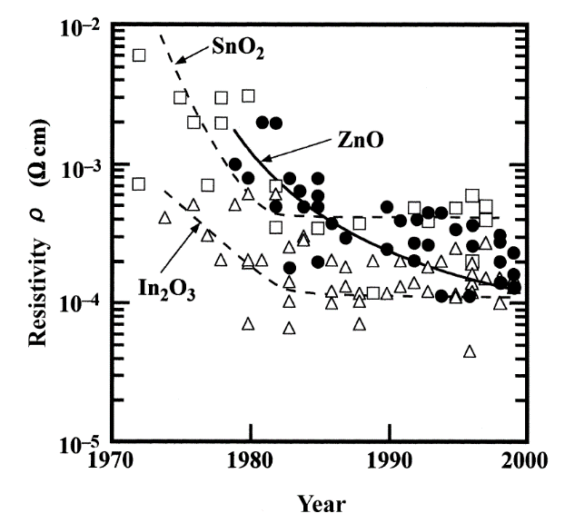

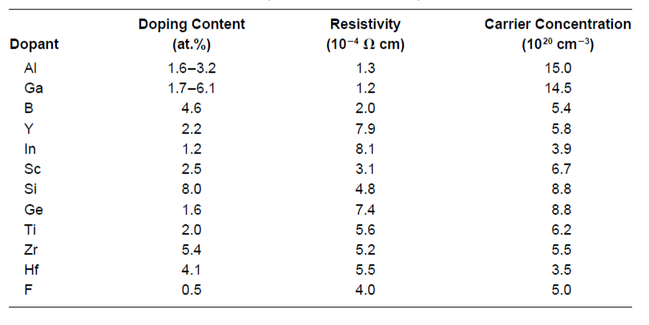

**Figure 3.6:** Reported (1970–2000) resistivities of binary transparent conducting oxide (TCO)

materials: undoped and impurity-doped SnO2(▯), In2O3 (△), and ZnO (**●**) [35].

**Table 3.2:** Resistivities, Carrier Concentrations, and Dopant Content for ZnO Films Doped with Various Impurities [35].

**3.2.5 Optical Properties:**

As was already noted, excellent TCO thin films should also have a very low absorption coefficient in the vicinity of UV, VIS, and NIR. Eg controls transmission in the near-UV area because photons with energies greater than Eg are absorbed. There aren't any "ideal" TCO thin films, and even if there were, interference and reflection would impede with the transmission. Therefore, achieving complete transparency over a large area is impossible.

The basic band gap of TCOs is rather big, which is a prerequisite for excellent transparency. However, highly n-type doped TCOs have a carrier concentration that may exceed 1021 cm3. The threshold of the transition may happen k points away from the zone center due to the Moss-Burstein effect. Additionally, in highly doped systems, a transition between the conduction bands is possible. The optical transitions between the occupied conduction states and the other conduction band states, as well as those between the valence bands and the unoccupied conduction band states, influence the optical properties of TCOs [38].

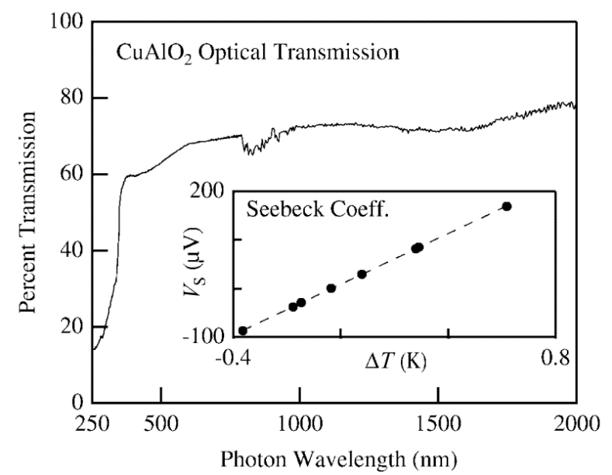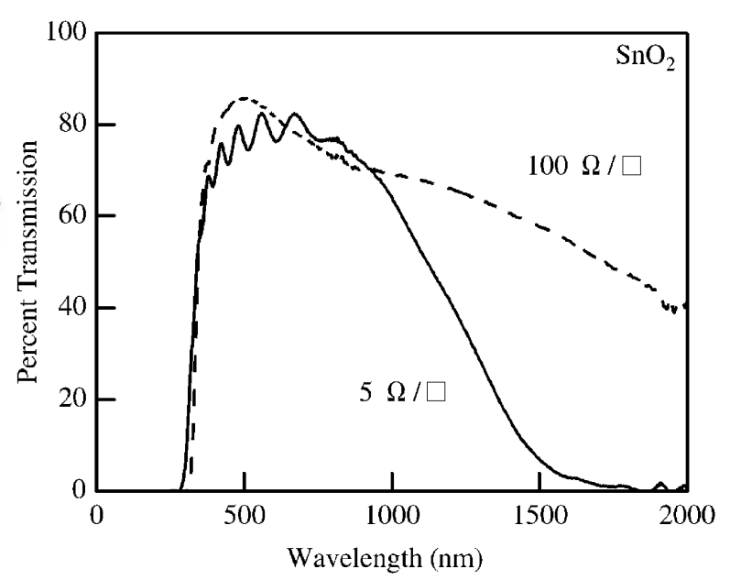

**Figure 3.8.** Optical transparency and Seeback data for a 300–500-nm-thick film of p-type CuAlO2 [39].

**Figure 3.7.** Optical transparency versus conductivity for two SnO2 films. As the resistivity decreases, long-wavelength transparency also decreases [39].

**3.2.6 Work function:**

The work function (f), which is the minimal amount of energy required to remove an electron from a metal, is determined by the energy difference between the Fermi energy level and vacuum level. The work function and ionization energy of metals are same. The work function can be significantly impacted by the surface's condition. The work function can be significantly altered by the presence of very small amounts of contamination (less than a monolayer of atoms or molecules) or by the occurrence of surface processes (oxidation, for example). Depending on the surface quality, changes of the order of 1 eV are typical for metals and semiconductors. These modifications are brought about by the development of electric dipoles at the surface, which alter the energy required for an electron to depart the sample. The work function is sensitive to chemical surface changes, hence measuring it can provide important information on the state of a specific surface [40]. The Fermi level is found within the band gap of a nondegenerate semiconductor, which has a moderate doping level. The energy difference between the valence bands maximum (VBM) and vacuum level (ionization energy) and work function are now different. Since there are no permitted electronic states within the band gap in a semiconductor, the Fermi level becomes more or less a theoretical parameter. This means that the Fermi distribution, a statistical function that estimates the likelihood of finding an electron in a particular electronic state, must be taken into account. The Fermi level is the region of the energy spectrum where probability is only 50%. Untreated AZO and ITO typically have work functions of 4.97 and 4.7 eV, respectively [41], whereas plasma cleaning of the TCO in O2 typically results in an increase in work function of between 0.1 and 0.3 eV.

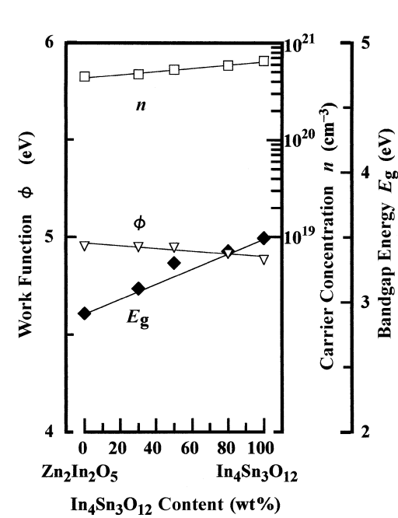

**Figure 3.8.1** Carrier concentration (▯), bandgap energy (◆), and work function ( ▽ ) as functions of In4Sn3O12 content for Zn2In2O5-In4Sn3O12 films prepared by rf MSD [35].

**3.2.7 Thermal and Chemical stability:**

The thermal stability temperature is the point at which the characteristics of TCO coatings noticeably alter or deteriorate. ZnO, SnO2, and Cd2SnO4 have reported thermal stability temperatures of 250°C, 500°C, and 700°C, respectively [13]. Above this temperature, the films undergo chemical decompositions that lower their quality. Temperature sensitivity of several commercial substrates (glass 500°C, polymer 200°C) limits the processing temperature. Additionally, observations of the TCO films' chemical interactions with the substrate and succeeding layers have been documented in the literature [43].

From an application standpoint, the created TCOs must have thermal stability because they may be subjected to a variety of harsh conditions. The ability of a TCO to withstand corrosive conditions and treatment determines the TCO's chemical stability. TCO sensitivity to decreasing atmospheres is a significant issue for applications like amorphous Si solar cells. When ITO is exposed to hydrogen conditions, it goes through a substantial decrease. In contrast, doped ZnO films are significantly more stable in plasmas and reducing atmospheres that contain hydrogen species [42]. As a result, ZnO-based TCOs might be chosen for applications involving the processing of hydrogen plasma. In contrast, ITO has more stability than other TCOs in oxidizing atmospheres, particularly at high temperatures.

**3.2.8 ZnO as TCOs:**

Zinc oxide has a wide range of uses as transparent conductive oxide (TCO) layers in many optoelectronic applications, including solar cells, optical detectors, biosensors, photoinduced nonlinear optical materials, and others. This is due to its special properties, including a wide band gap of about 3.37 eV and a hexagonal crystal structure.

Recent research centered on techniques that improved electron transport across the flaws and inherent faults in the crystal structure of zinc oxide. The optoelectronic properties of the thin films can significantly alter as a result of optimizing these circumstances. The density of crystal defects (such as Oi, VZn, Zni, OZn, and VO) is altered by adding the dopants from group "III" of the periodic table (B, Al, Ga, and In) and substituting each of them for the Zn atoms. This forms the 3+ ions of donor impurity that can provide an extra electron. Therefore, altering electron traps can greatly improve carrier movement inside the crystal structure. Al impurity among the group III elements has been utilized as a dopant significantly more frequently than the others due to its abundance and stability.

The AZO thin films have been created using several physical and chemical methods. However, the Sol gel process, followed by spin coating, does not require any complicated high vacuum apparatus and is typically used to prepare AZO thin films at ambient temperature.

Due of the wide range of applications for AZO layers, there are several articles about the precursor to its synthesis and the thin film technique, most of which concentrate on the Al atomic percentage.

However, it has never been mentioned before how the host substance (zinc oxide) might absorb the contaminant (aluminum). In truth, there is still no answer to the question of what the intrinsic zinc oxide layer's (the host material) suitable structure is for tolerating the ideal amount of impurity [44].A transparent conductive oxide (TCO) can serve as a solar cell's top electrode. The resistivity should be as low as feasible, while the carrier concentration is decreased to avoid undesirable free carrier absorption in the infra-red spectrum, for a TCO to be effective as an electrode (front and back). Using pulsed laser deposition, Ga-doped ZnO is formed on quartz substrates, however the mobility of the carriers must be as high as possible to boost the TCO's conductivity while maintaining a low absorption coefficient [45]. For a sample placed at 300°C, a resistivity of 8.12 105 cm and a visual transmittance of more than 90% were found. The study of the ZnO/Ag composite thin film structure revealed a considerable reduction in resistivity value with great transparency [46]. The team created sandwich-type ZnO/Ag thin film/ZnO multilayer structures, as those in scheme Figure 3.9.



**Figure 3.9:** Schematics of (a) ZnO/ Ag film/ZnO structure with an Ag thin film layer between two transparent ZnO layers. (b) ZnO/Ag grid/ZnO structure in which the Ag grid is inserted. (c) ZnO/AgNW/ZnO structure in which an Ag nanowire network is present instead of an Ag thin film. Reproduced from ref. [46].

The insertion of an ultrathin silver film with the lowest resistivity (1.6*10-6 Ω-cm) can dramatically lower the sheet resistance, while the thin film at the nanometer scale can transmit visible light.

**3.3 LED:**

Solid-state lighting businesses have advanced quickly over the years in both developing new ideas and enhancing the functionality of current light-emitting diodes (LEDs).This was because LEDs were more acceptable than incandescent and compact fluorescent lights due to their improved thermal performance, longer lifespan, affordable price, dependability, and environmental friendliness. LEDs may now be integrated into increasingly intricate and rugged locations because to the ongoing downsizing of LED casings and rise in power densities. But as power densities rise and enclosures become smaller, heat dissipation problems frequently accompany them. As a result, a lot of heat builds up inside the device in addition to the LED overheating, which causes the device's thermal and brightness output performance to degrade. LEDs must have a dependable and efficient thermal management system to maintain their thermal and brightness output performance. Thermal interface materials (TIMs) are typically used at the bottom of LEDs as a medium that helps heat dissipate from LED's enclosure in order to alleviate LEDs' thermal management challenges. There are many types of commercially available TIMs, including polymer or silicone composite adhesives, thermal pads, thermal grease, thermal paste, phase transition materials, and thermal fluids.

Commercially available TIMs are constrained in their potential use for LED thermal management due to factors such as low thermal conductivity, high interface resistance, high conductance, high thickness, which typically cause stack up tolerance, and pump out, messy, and dry out of the materials when used. To achieve an efficient heat dissipation rate, researchers have recently focused more on producing TIMs with excellent thermal conductivity.Recently, solid thin film TIMs were created as an alternative to the already available commercial TIMs. The low hardness and high thermal conductivity metal or ceramics from Ag, Al, Cu, Zn, BN, AlN, SiC, MgO, Al2O3, SiO, or a combination of any two (B-AlN, Ag-ZnO, Mg-ZnO, Cu-Al2O3, MgO-SiC, or MgO/ZnO) were coated over a metal substrate to create the solid thin films. In order to create a composite material with a notable high thermal conductivity and a low surface roughness to ensure good contact conductance between an LED enclosure and a heat sink, thin films (TIMs) with optimum or low thickness are deposited over Al or Cu substrates [47].

An LED is a p-n junction, where the current is injected in the forward bias and p-type and n-type materials are brought together. Then, the holes on the p-side and the uncompensated acceptors on the n-side will diffuse to the opposite side, leaving behind the respective electrons and holes. An electric field will develop in the transition (depletion) area as more carriers diffuse, blocking further diffusion. The potential difference between the n- and p-sides is known as the contact potential, and band bending takes place to maintain the Fermi level constant throughout the device.

The carrier diffusion caused by the concentration gradient and the carrier drift caused by the electrical field in the transition zone cancel each other out when the junction is in equilibrium, producing no net current. In the neutral (depletion) region of the p-n junction, e- and h+ recombinations take place as current is transmitted through the device in forward bias. In a direct band gap semiconductor, excited electrons and holes combine and release energy by producing photons. The hue of the emitted light will match the band gap energy [48]. ZnO is well suited for LED technology because electrons and holes generate tightly bound excitons, which facilitate near-band gap recombinations at ambient temperature. Very active optical characteristics can be seen in ZnO nanostructure.

The defect states present in the nanostructures are related with higher UV emission and dry low emission in the visible region in the photoluminescence (PL) spectra of ZnO. Light is emitted in the visible spectrum when transitions through defect states take place, and emission at various wavelengths occurs from transitions from distinct defect states. There have been reports on ZnO sheets emitting green, red, and blue light [49]. However, the intensity of the emission must be quite high to be taken into account for device applications. By externally doping the ZnO host lattice with dopants, the strong emission can be produced.

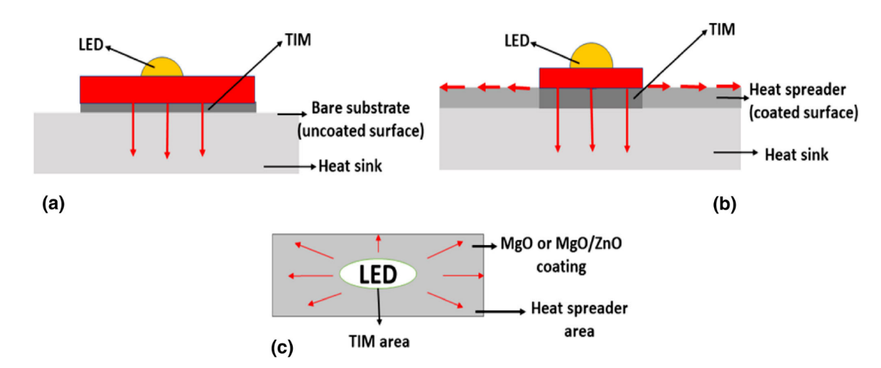

**Fig 3.10.** illustration of LED mounted on TIM and showing heat dissipation via (a) the TIM only, (b) the TIM and through the in-plane direction (coated and exposed area to the ambient), (c) top view of (b) [47].

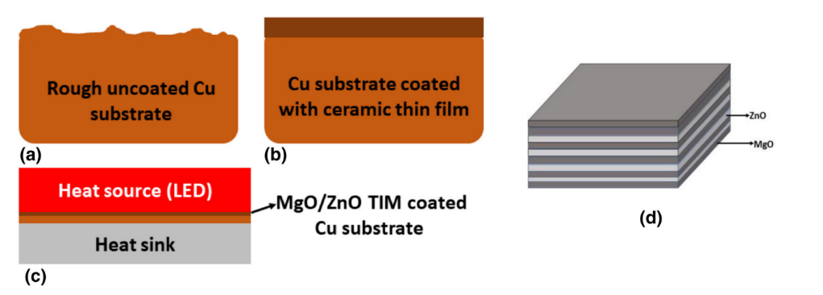

**Fig 3.11:** Illustration of (a) uncoated Cu substrate, (b) MgO/ZnO TIM coated over Cu substrate and (c) sandwiched between high power LED and heat sink to eliminate air gaps created due to their respective rough surfaces and (d) An illustration of stacking of MgO and ZnO layers [47].

**3.4 ZnO:**

**3.4.1 Crystal Structure of ZnO:**

Wurtzite is the thermodynamically stable phase of the semiconductor compound ZnO at ambient temperatures. As shown in Figure 3.12, ZnO has a hexagonal unit cell and the determined lattice parameters of a = b = 3.2495 ( 0.00002) and c = 5.2069 ( 0.0001). It also belongs to the space group P63mc.The lattice parameters "a" and "c" in the wurtzite structure have a ratio of c/a=1.66 and make up each hexagonal unit cell.The structure is made up of two interlocking hexagonal-close-packed (hcp) sub lattices, each of which has one type of atom that is moved away from the other along the three fold c-axis by a distance of u=3/8=0.375 (in the ideal wurtzite structure) in fractional coordinates. The u parameter is defined as the length of the bond that runs parallel to the c axis, in units of c. The four atoms in each unit cell of each sub lattice are coordinated at the corners of a tetrahedron, and every atom of one kind (group-II atom) is surrounded by four atoms of the other kind (group-VI), or vice versa. These tetrahedrons typically feature sp3 covalent bonds, but they also have strong ionic characteristics that tend to make the band gap larger than would be predicted from covalent bonding. The wurtzite structure of actual ZnO crystals deviates from the ideal configuration by altering the c/a ratio. The structure is made up of AaBbAaBb... bi-atomic (0001) planes that alternate with one another [50].



**Figure 3.12:** Illustration of wurtzite ZnO in its hexagonal unit cell (a) and more atoms added to illustrate the alternating biatomic planes (b). The cell parameters are a = b = 3.2495 Å and c = 5.2069 Å. Figure (b) was created using the VESTA software [51].The positive z direction for the crystal is the [0001] axis which points from the face of the oxygen plane to the zinc plane. Bonds along the c direction going from an zinc cation to an oxygen anion has a Zn polarity, and the opposite is true for bonding from oxygen to zinc and the two sides of the crystal is called Zn-face [0001] and O-face [000¯1].

In the above picture, three types of zones are observed. All zones have distinct crystal orientations and characteristics.

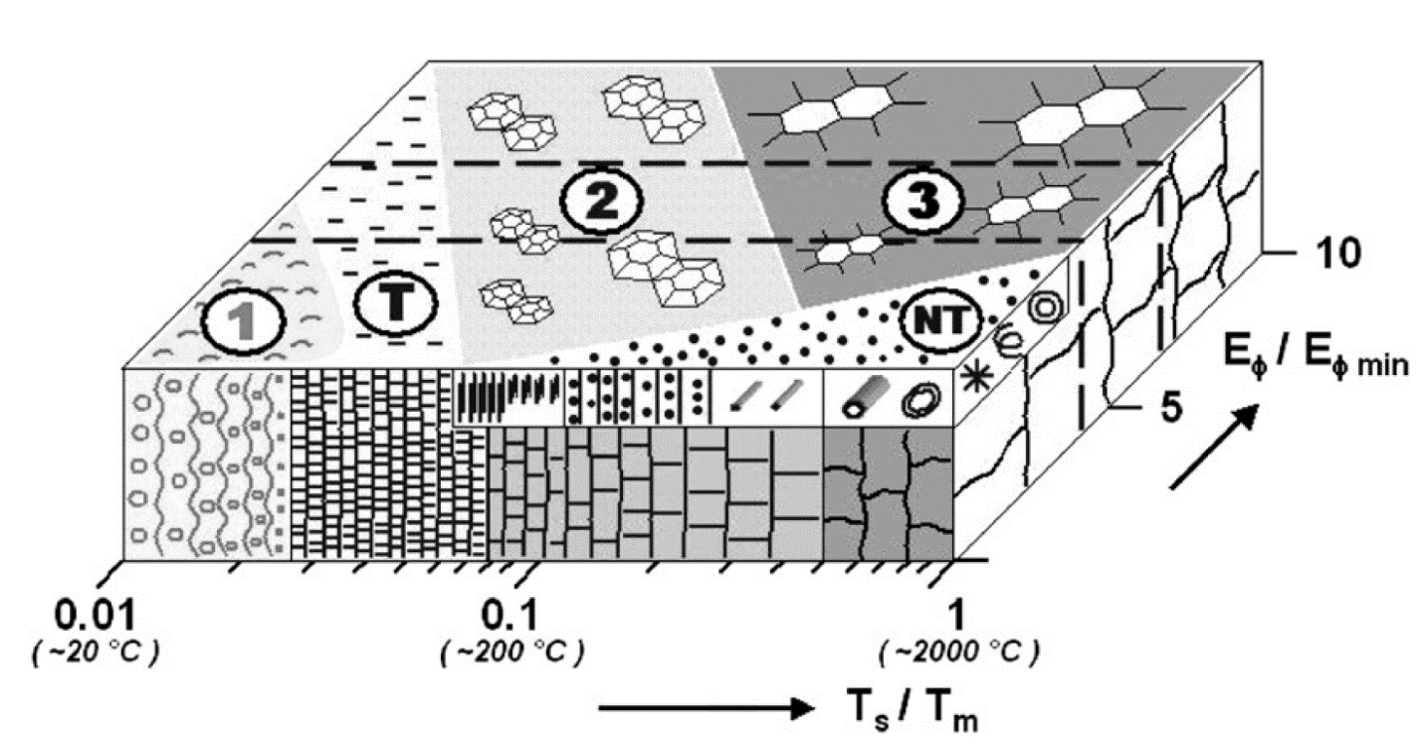

**Fig 3.13:** Crystalline structure zone model of sputtered ZnO thin films [52]

**Zone 1:** This is a porous structure having tapered amorphous or crystalline nanograins separated by voids.

**Zone T:** This is a dense polycrystalline structure having fibrous and nanocrystalline grains.

**Zone 2:** This is a columnar grain structure.

**Zone 3:** This is a single-crystal micro-grain structure.

**Zone NT:** This is a zone of nanostructures and nanoelements.

**3.4.2 Defects in ZnO:**

In applications that take advantage of the diverse range of doped ZnO's capabilities, the control of imperfections and related charge carriers is of utmost importance. Solid surfaces, however, have distinct impurities, adsorbed gases that serve as electron sources and sinks, and connected space charge regions. Small length scales and a high surface-to-volume ratio in nanostructured ZnO (and other materials) lead to a larger influence of surface imperfections on characteristics. Understanding the flaws in ZnO that have been intentionally doped with aliovalent ions to achieve a certain functionality or accidentally doped during the growing process is equally crucial. Numerous intrinsic flaws with various ionization energies exist. i stands for the interstitial site, Zn for zinc, O for oxygen, and V for vacancy in the Kröger Vink notation. The terms denote the atomic sites, and the superscripted terms denote the charges. The charges are proportional to the number of symbols, with a dot denoting a positive charge, a prime denoting a negative charge, and a cross denoting zero charge. The bandgap of ZnO contains a variety of defect states, as shown in Fig. 3.14. The acceptor defects are VZn'', VZn', and the donor defects are Zni ••, Zni•, Zni*, VO ••, VO •, and VO [53].

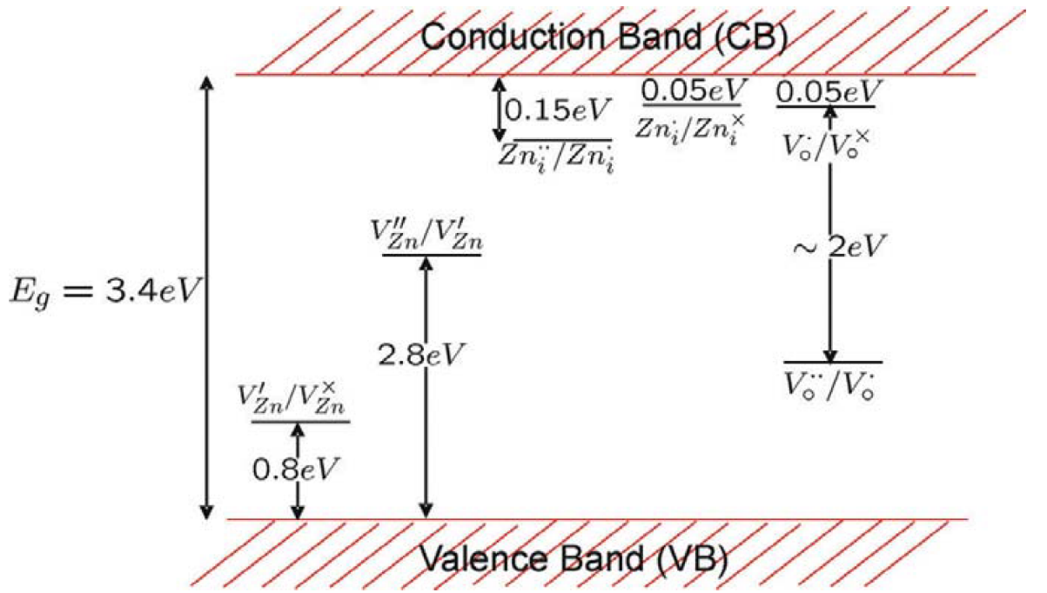

**Figure 3.14:** Energy levels of native defects in ZnO. Reproduced from ref. [53].

The energies of defect ionization range from 0.05 to 2.8 eV. The most common ionic defect types are known to be oxygen vacancies and Zn interstitials. It is still up for debate as to which fault predominates in native, undoped ZnO.

**3.4.3 n-type ZnO:**

Since wurtzite-structured ZnO deviates from stoichiometry due to the presence of intrinsic defects such O vacancies and Zn interstitials, it is by nature an n-type semiconductor. With extremely high electron densities of about 1021 cm3.400, undoped ZnO exhibits intrinsic n-type conductivity. Although it has been demonstrated in experiments that accidentally doped ZnO is of the n type, it is still debatable as to whether Zni and VO are the donors. Group-III elements Al, Ga, and In can be employed as n-type dopants in ZnO to execute n-type substitutions for Zn as well as group-VII elements Cl and I to accomplish n-type substitutions for O [54]. Numerous teams have experimented with doping with Al, Ga, and In, producing excellent, highly conductive n-type ZnO films as a result. Such films are successfully used in a variety of applications, including transparent Ohmic connections and n-type layers in light-emitting diodes.

**3.5 Thin Film Deposition Techniques**

Since all microelectronic solid-state devices are built on material structures produced by thin-film deposition, deposition technology can be considered to be a key component in the development of devices like computers. Deposition technology has had to quickly advance in response to the constant demands of electronic engineers for films with higher levels of sophistication and quality for solid-state devices.

The requirements for better and more affordable deposition systems, as well as for in-situ process monitors and controls for measuring film parameters, have been successfully met by equipment manufacturers. The improved knowledge of the physics and chemistry of films, surfaces, interfaces, and microstructures made possible by the remarkable developments in analytical instrumentation over the past 20 years is a significant factor in the quick development of deposition technology. Improved fundamental knowledge of materials results in broader applications and new device designs that use these materials. Coatings with a thickness of between 5 Angstroms and a few micrometers are referred to as thin films [55].

On passive substrates like glass or ceramic as well as active substrates like silicon, various materials may be deposited as thin films. Thin-film deposition is the process of depositing a thin film on a surface.

The process of depositing a thin layer of material onto a substrate or onto previously applied layers is known as thin film deposition. Although the term "thin" is ambiguous, most deposition techniques allow layer thickness to be controlled to within a few tens of nanometers, and one (molecular beam epitaxy) even permits the deposition of single layers of atoms at a time.

It can be used to create packaging (like aluminum-coated PET film), electronics (layers of insulators, semiconductors, and conductors form integrated circuits), optics (for reflective or anti-reflective coatings, for example), and modern art. Where thickness is not crucial, similar processes are occasionally applied. For instance, copper can be purified by electroplating, and silicon and enriched uranium can be deposited using a method akin to CVD after gas-phase processing.

**3.5.1 Classification:**

Deposition techniques fall into two broad categories:

1. **Chemical Techniques**
2. **Physical Techniques**
3. **Chemical Techniques**

These procedures take advantage of the fact that solid materials can be produced directly from chemical reactions that take place in liquid or gaseous compositions or with the substrate. In most cases, the reaction produces additional products in addition to the solid material. Gases, liquids, and even additional solids are examples of byproducts. Chemical deposition techniques produce thin films that are typically conformal rather than directional.

Depositions that happen because of a chemical reaction are as follows:

* **Chemical Vapor Deposition (CVD**)
* **Electrodeposition**
* **Epitaxy**
* **Thermal oxidation**

1. **Physical Techniques**

A thin solid film is created by physical deposition using mechanical or thermodynamic methods. The material being deposited on the substrate is physically moved in all of these processes. In other words, the substance that forms on the substrate does not result from a chemical reaction. Although it is more convenient to think of casting processes in this way, it is not entirely accurate. As a result of the ongoing development of technology, this list is by no means complete.

Deposits that result from a physical reaction:

* **Physical Vapor Deposition (CVD**)
* **Casting**
* **Molecular beam epitaxy**
* **Thermal evaporation**

The classification of the different deposition processes is illustrated in the Figure 3.15:

**Deposition Techniques**

**Chemical Deposition Techniques**

**Physical Deposition Techniques**

**Evaporation**

**Sputtering**

**Magnetron**

**DC**

**Radio Frequency**

**Solution Based**

**Spin coating**

**Chemical spray Pyrolysis**

**CVD**

**Atmospheric Pressure**

**Low Pressure**

**Electron Cyclotron**

**Plasma Enhanced**

**Metal Organic**

**Electroless Deposition**

**Electroplating**

**Atomic Layer Deposition**

**Sol-gel**

**Planting**

**Loan Plating**

**Thermal**

**Electron Beam**

**Laser Ablation**

**Molecular Beam Epitaxy**

**Figure 3.15:** Classification of different film deposition techniques. Reproduced from ref. [56]

**3.5.2 Atomic Layer Deposition:**

The atomic layer deposition technique can be controlled by deposition temperature. The (10.0) orientation have high growth in the temperature ranged between 155°c-220°c and (00.2) orientation have it at high temperature, such as 280°c. And in the range of 130°c, both of (10.0) and (00.2) have preferential growth. Therefore, it is proved that degree of crystallinity in film growth is the function of deposition temperature. For any type of deposition technique, determining the preferential orientation and controlling it have a great importance in the sector of materials science [57]. There are some conditions under which the preferential growth of film can be achievable. Generally, the growth happens due to minimize the surface free energy, and in the equilibrium condition the film grows along the plane which have lowest surface free energy and its direction is parallel to the surface. But it should maintain its temperature below roughening temperature and should not have any influence of epitaxy [58]. As the (00.2) orientation have high atomic packing density and minimum surface free energy, it is the highest probable growing orientation for ZnO by the atomic layer deposition. So, the direction [0001] is the thermodynamically preferable direction for the ZnO of wurtzite structure. Here, the atomic layer deposition was done using Diethyl zinc (DEZn) as the source of zinc and water as the source of oxygen. In this deposition method, the zinc and oxygen deposits alternatively to grow the film.

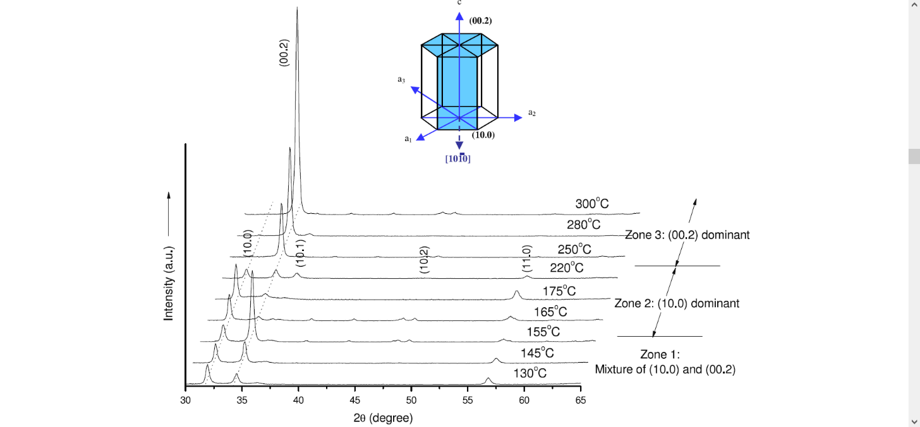**Fig 3.16:** The relationship between growth intensity and orientation at different deposition temperature in XRD analysis [59].

**3.5.3 Pulsed Laser Deposition:**

The pulsed laser deposition technique has good scope in the development of epitaxial films. It allows the fabrication of multi-layers and hetero-structures. It can also use in the super lattices. [62] The films which grows through PLD process, has wide range of deposition conditions, which was observed as high optical transparency, electrical conductivity and c-axis oriented having FWHM (Full Width at Half Maximum). In the XRD analysis, the (002) orientations have reflection line less than 0.25°. At room temperature, all the deposited layers were found as amorphous form, no sharp XRD reflection line was found, and exhibited matt surface. At 200°c- 500°c temperature on the substrate, the films which were grown all in c-axis oriented. Then (002) and (004) lines were exhibited, no other lines were found. For wide range of fluences and oxygen partial pressures, the full width at half-maximum of the (002) line was found in less than 0.25° which indicates that it has high quality crystalline structure. The beneficial effects were found from 150°c to 350°c temperature range. But the opposite effects were found above the 400°c. Most of the films which are observed in this study were grown in 350°c. By the observations of various effects which are shown on different partial oxygen pressures, it was shown that best quality films could be obtained in the high-pressure range [60].

**3.5.4 Sputtering Techniques:**

In the previous section we discussed about the chemical and physical methods where the chemical methods have better performance rather than the physical methods. The sputtering techniques have better performance over the chemical process due to its good control of compositions and homogeneity.

The process initialized by the energetic bombardment of substrate, which is assisted by neutral atoms, electrons and ions. This is characterized by total energy flux density which affects the film. And the total energy flux density can be calculated by radio-frequency (RF) power, bias voltage of substrate and concentration of reactive gases. Here the major parameters are total energy flux density and substrate temperature which provide significant role on the crystalline structure of the film. These two parameters have significant influence on the initial phases of film growth like nucleation, clustering or film growth [61].

**3.5.4.1 Mechanism:**

During sputtering, electrons, ions or atoms are ejected from a material (solid phase) with particles having high energy, typically more than 1 eV. Maintaining conditions like low pressure and high voltage are important so that the plasma consisting of energized electrons can be generated properly. This is called as glow discharge process. Here the cathode performed as target, and the anode as substrate. So, it can also say that, the electrons ejected from the source which is cathodic and anode as substrate. Therefore, the electrons diffuse away and deposited on the anodic substrate. For conducting samples, DC voltage is applied between anode and cathode which is referred as DC sputtering. Amount of DC voltage depended upon the nature of the substrate. On the other hand, for non-conducting samples or insulating materials radio frequency generator of high of high frequency is used [62].

**3.5.4.2 Magnetron Sputtering:**

In magnetron sputtering, magnets are used which increases the amounts of electrons. That’s why, it has good impact on Ar atoms. Therefore, the path length of electrons increases as well as the ionization efficiency. Magnetron sputtering are used where there are high deposition rates and low substrate temperature are required. In this process both DC and RF mechanism are used. In this mechanism, ejected species with high energy can increase the temperature of the surface which can influence on the crystallinity of the thin film, or may cause damages to the surfaces or films or both. In this process if the bombarding particle have sufficient energy, then it can implant itself into the film, or may be damage the film, or can transfer its momentum to a surface atom [63].

**DC Sputtering:** In this sputtering technique, several semiconductor components and printed circuit board can be constructed. This is a plasma technique in which plasma near the deposition source can increase by using magnetic field. This sputtering can be initiated by igniting a glow discharge or plasma through a large DC bias which is situated between a cathode and an anode. This process is done in a vacuum environment.

**RF Sputtering:** In this technique, deposition of oxide layers like semiconducting ZnO is done. In comparison with the DC method, this has advantages as it involve RF power. Therefore, by this process, operation can be formed in low working gas pressure conditions. The insulating or non-conducting target which need to deposit is attached with one of the electrodes.

**3.5.5 Sol gel process:**

This is basically a chemical method which is done in wetted condition. This process is used in the formation of nano-structured particles. For the synthesis of ZnO based nanoparticles or ZnO thin films, The sol-gel method is a very common one. A molecular precursor like metal alkoxide can dissolve in the water or alcohol. Then it is converted into the gel by hydrolysis.

**3.5.5.1 Mechanism:**

The sol-gel process, depicted in figure 3.17, is a technique used in materials science to create solid materials from small molecules. The technique is employed to create metal oxides. During the procedure, monomers are transformed into a colloidal solution (sol), which serves as the precursor for an integrated network (or gel) of discrete particles or network polymers. Metal alkoxides are typical precursors.

The irregular particle sizes and shapes in a typical powder frequently result in non-uniform packing morphologies that cause packing density variations in the powder compact when processing fine ceramics. Microstructural inhomogeneities can also result from uncontrolled flocculation of powders brought on by attractive van der Waals forces. The rate at which the solvent can be removed directly affects the differential stresses that result from non-uniform drying shrinkage, making porosity distribution an important factor. If not relieved, these stresses can lead to crack propagation in the unfired body and have been linked to a plastic-to-brittle transition in consolidated bodies. Furthermore, any variations in the compact's packing density as it is being readied for the kiln are frequently amplified during the sintering process, leading to inhomogeneous densification. It has been demonstrated that some pores and other structural flaws connected to density variations can hinder the sintering process by expanding and thereby restricting end-point densities. It has also been demonstrated that differential stresses brought on by inhomogeneous densification cause internal cracks to spread, becoming the flaws that regulate strength.



**Figure 3.17** Basics of synthesis by sol gel methodology

Instead of using particle size distributions that will maximize the green density, it would therefore seem preferable to process a material in a way that it is physically uniform with regard to the distribution of components and porosity. Total control over particle-particle interactions is necessary for the containment of a strongly interacting assembly of uniformly dispersed particles in suspension. It is possible in monodisperse colloids.

For instance, colloidal silica monodisperse powders may be sufficiently stabilized to guarantee a high level of order in the resulting colloidal crystal or polycrystalline colloidal solid. The amount of time and space that can be used to establish longer-range correlations appears to be a limiting factor in the degree of order. The first step in developing a more thorough understanding of the mechanisms underlying microstructural evolution in inorganic systems, such as sintered ceramic nanomaterials, is to identify such defective polycrystalline structures as the fundamental building blocks of nanoscale materials science.

Products made from sol gel have a wide range of uses. For instance, it has been used by scientists to create some of the world's toughest ceramics as well as the world's lightest materials. Thin films, which can be created on a piece of substrate by spin coating or dip coating, are one of the most common application areas. These techniques can be used to apply protective and decorative coatings as well as electro-optic components to glass, metal, and other types of substrates. Dense ceramic or glass objects with novel properties that can only be produced this way can be cast into a mold and then further dried and heated. Spraying, electrophoresis, inkjet printing, and roll coating are additional coating techniques.

**3.5.5.2 Sol gel coating technique:**

The sol-gel method is a low-temperature method for creating metal oxide molecules in solution form from inorganic or metal organic precursors. The process of creating the solution relies on the condensation and hydrolysis of organometallic compounds in alcohol-based solutions. Following that, a number of techniques, including spin coating, can be used to deposit CCZO films using the solutions.

**3.5.5.2.1 Spin coating**

In the spin-coating method, the substance to be deposited is dissolved or dispersed in a solvent, which is then applied to the substrate surface and spun off to leave a thin, uniform layer of film. Figure 3.18 depicts the four main stages of the spin-coating process, which are as follows:

**1.** The solution is deposited on the substrate.

**2.** Solution spreading outward (spinning up) from the substrate's center to the sides.

**3.** Spin-off, or gradual solution thinness.

**4.** The evaporation of a solvent cause gelation.



**Figure 3.18** A schematic of spin-coat deposition*.*

Since a balance between the radially outward centrifugal force and the radially inward viscous force occurs, the deposited film tends to be uniform as it is thinned by centrifugal draining. It is possible to achieve extremely homogeneous film thicknesses even with non-planar substrates.

**3.5.5.2.2 Dip coating**

In this method, the substrate to be coated is submerged in the solution and then removed under controlled temperature and atmospheric conditions at a predetermined speed. Figure 3.19 displays a schematic. Smooth substrate movement and vibration-free mountings are crucial for maintaining a consistent film thickness. Dip-coating requires more sophisticated equipment than spin-coating does.



**Figure 3.19** A schematic of dip-coat deposition.

**3.5.5.2.3 Solgel spin coating techniques**

There are two types of spin coating methods:

**Static process:**

At first solvent is applied and after that rotation started.



**Figure 3.20:** Static spin coating technique

**Dynamic process:** After starting the rotation, the speed is initially low and then quickly rises. During the period of low speed, solvent is administered.

**Figure 3.21:** Dynamic spin coating technique

**3.5.5.2.4 Advantages and Disadvantages of Spin Coating**

The benefits of spin coating include the thin and homogeneous coating that can be produced along with how simple and relatively easy it is to set up a process. High airflow and quick drying periods derive from the capacity to spin materials at high speeds, which in turn produces great consistency at both macroscopic and nanoscale length scales.

Spin coating has the drawback of being a batch (single substrate) process by nature, which results in a lower throughput than roll-to-roll techniques. Some specific nanotechnologies that need time to self-assemble and/or crystallize may function worse due to the quick drying times. Last but not least, only about 10% or less of the actual material used in a spin coating process is actually utilized; the remainder is wasted and thrown off to the side. While this is typically not a problem in research settings, it is obviously wasteful in manufacturing.

Spin coating is frequently the starting point and benchmark for most academic and industrial operations that call for a thin and homogeneous coating, despite these limitations.

**3.5.5.2.5 Advantages and Disadvantages of the Sol-Gel Technique**

Sol-gel coatings have several advantages over other processes for the creation of thin films since they are a solution processable technology. These includes:

**1)** Excellent control over the coating solutions' stoichiometry and purity.

**2)** The simplicity of compositional changes.

**3)** Eligibility for deposition on substrates with broad surfaces.

**4)** Basic and affordable tools

The resulting films' sheet resistance typically exceeds that of the sputter-coated films by at least one order of magnitude, which is a drawback. One cause could be that there are many more parameters in sol-gel processes that need to be optimized.

The properties of the produced thin films may be significantly influenced by the precursors used, the number of layers deposited, the drying and annealing temperatures, and the environment. Additionally, good quality films are less repeatable than sputter-coated ones since sol-gel methods need a lot more manual labor. However, with thorough optimization and process control, this technology has a great deal of potential to replace current low-cost deposition methods [64].

**3.6 Characterization Principles**

Thin film characterization is a crucial aspect of materials science and engineering, playing a significant role in various industries and research fields. Thin films are thin layers of material deposited onto a substrate, and they are utilized in a wide range of applications, including electronics, optics, coatings, and more. Characterizing these thin films is essential for several reasons:

**Quality Control:** Thin film characterization helps ensure the quality and consistency of thin films in terms of thickness, composition, and other properties. This is vital for manufacturing processes, especially in industries such as microelectronics and optoelectronics.

**Performance Optimization:** Understanding the properties of thin films allows researchers and engineers to optimize their performance for specific applications. This includes tailoring the thickness, refractive index, and other characteristics to achieve desired functionality.

**Device Fabrication:** Many electronic and optical devices rely on thin films. Characterization is crucial during the fabrication process to ensure that the thin films meet the required specifications for the devices to function as intended

**Understanding Physical Properties:** Thin film characterization provides insights into the physical and chemical properties of materials at the nanoscale. This is essential for advancing our understanding of material behavior and for developing new materials with enhanced properties.

**Research and Development:** In research, thin film characterization helps scientists explore new materials and develop innovative technologies. It contributes to advancements in areas such as nanotechnology, sensors, solar cells, and more.

**Diagnostic Tool:** Characterization techniques, such as spectroscopy and imaging, serve as diagnostic tools to identify defects, impurities, or other issues within thin films. This information is crucial for troubleshooting and improving manufacturing processes.

**Optical and Electronic Properties:** Thin films often exhibit unique optical and electronic properties that differ from bulk materials. Characterization helps in studying these properties, enabling the design of devices with specific functionalities.

**Advancements in Nanotechnology:** As nanotechnology continues to evolve, thin film characterization becomes even more critical. The ability to precisely analyze and control thin film properties is essential for developing nanoscale devices and structures.

Common techniques for thin film characterization include ellipsometry, X-ray diffraction, atomic force microscopy, scanning electron microscopy, and various spectroscopic methods.

In summary, thin film characterization is indispensable for ensuring the quality, performance, and functionality of thin films, contributing to advancements in technology and materials science.

**3.6.1 Structural studies**

Here, the methods used to look into the morphological and structural characteristics of thin films have been described. These methods include scanning electron microscopy (SEM) for surface morphological characterization and X-ray diffraction (XRD) for structural characterization. The structural studies of thin film technology involve examining and understanding the arrangement, composition, and morphology of thin films at the atomic and nanoscale levels.

These studies are crucial for optimizing the properties of thin films for specific applications. Structural characterization techniques are essential for tailoring thin film properties to meet specific application requirements. Researchers use the information obtained from these studies to optimize deposition processes, understand growth mechanisms, and design thin films with desired structural characteristics for applications in electronics, optics, sensors, and more.

**3.6.1.1 XRD**

The most accurate method for determining the crystal structure of solids is X-ray diffraction, which typically doesn't call for extensive sample preparation and is basically nondestructive [65]. Utilizing X-ray diffraction, thin surface films up to 1000 thick can be examined. RHEED, or reflection high energy electron diffraction, can be used to identify thicker films. The Joint Committee of Powder Diffraction Standards (JCPDS), which discloses the presence of several crystallographic phases in the film, their relative abundance, the lattice parameters, and the preferred orientations, can be used to compare the XRD-derived diffracted patterns.

The ability to distinguish between single crystals and polycrystalline deposits with random distributions of orientation with respect to the coating plane is necessary. Knowing the direction of a single crystal coating in regard to the substrate is crucial. Whether the sample is a single crystal or polycrystals [65], either with a random distribution of orientations or with a preferential orientation with respect to the film plane, X-ray diffraction is an appropriate method for figuring out the crystal structure of any unknown materials.

Peaks of dispersed intensity that correspond to the following circumstances are seen when x-rays are scattered from a crystal lattice:

**I.** The incidence angle = the scattering angle.

**II.** The difference in path length corresponds to an integer number of wavelengths.

When crystalline substances are subjected to X-rays, interference between the waves scattered by the atoms happens. Depending on how the waves overlap, interference can take one of two different forms. When the waves are travelling in phase with one another, as schematically depicted in Figure 3.22, constructive interference occurs. When the waves are out of phase, destructive interference takes place.

Bragg's Law, which describes the relationship between the angle at which an X-ray beam of a specific wavelength diffracts from a crystalline surface, was found by Sir William H. Bragg and Sir W. Lawrence Bragg: Where dhkl is the distance between the crystal plane for the Wurtzite structure ZnO unit cell, it is calculated using the following relation:

$\frac{1}{d_{hkl}^{2}}= \frac{4(h^{2}+hk+k^{2})}{3a^{2}}+\frac{1}{c^{2}}$**… … … … … (2.3)**

a, c are lattice constants. θ is the X-ray incident angle; λ is the wavelength of the X-ray and n is a positive integer. Bragg’s law also suggests that the diffraction is only possible when λ<2d.



**Figure 3.22:** X-ray diffraction from Bragg planes. Reproduced from ref. [66]

It is feasible to determine the crystallite size of the film by estimating the width of the diffraction line. The Scherrer equation, often known as the X-ay line broadening, is frequently used to calculate crystallite size and is denoted as follows:

**D = kλ/ βcosθ**

Where is the full width at half maximum (FWHM) of the peak in radians, is the angle of incidence in degrees, and is the wavelength of the radiation utilized as the primary beam of CuK (= 1.54178 ). K is the dimensionless constant, typically having a value of 0.9. The strain (ε) is calculated using the relations below:

$ε=\frac{βcosθ}{4}$**…. …. …. …. (2.4)**

The dislocation density (δ) is calculated from the following relation using the straightforward Williamson and Smallman method. It is defined as the length of the dislocation lines per unit volume of the crystal.

$δ=\frac{1}{D^{2}}$**…. …. …. …. (2.4)**

By using an X-ray diffractometer (Model: BRUKAR D8 ADVANCE), the structural characterization of the deposited films was performed, as shown in Figure 3.23



**Figure 3.23:** Photograph of X-ray diffractometer (Model: BRUKAR D8 ADVANCE)

**3.6.1.2 SEM**

One of the best methods for examining the surface morphology of thin films is scanning electron microscopy, or SEM. The specimen is excited using a high energy electron beam, which causes many interactions with the atoms of the target material. A SEM may collect a variety of signals, including secondary electrons, recognizable X-rays, and back scattered electrons. In order to create an image, the signals are gathered and examined as indicated in Figure. The signals convey information about the surface topology, chemistry, and crystallography of the materials.



**Figure 3.24:** Schematic diagram of the SEM working principle. Reproduced from ref. [67].

These signals in a SEM are produced by interactions within the sample close to the surface as well as by the primary beam impinging on the sample [67]. A schematic diagram of the SEM's operation is shown in Figure 3.24. In its principal use mode, secondary electron imaging, the SEM can provide high resolution images of a sample surface.

Additionally, it demonstrates the capability of secondary electron imaging, which is its major application, to generate high resolution images of a sample surface. SEM images have a significant depth of field as a result of the way they are produced, giving them a distinctive three-dimensional appearance that is helpful for comprehending the surface structure of a material.

The SEM's most popular imaging mode for specimens has a large depth of field and a variety of magnifications. When the primary beam induces the ejection of inner shell electrons from the sample, characteristic X rays are released, which can be utilized to determine the elemental makeup of the sample.

Backscattered electrons from the sample can be utilized alone to create an image or in combination with the distinctive X-rays to provide atomic number contrast hints about the sample's elemental makeup.

**3.6.2 Optical Studies**

Optical studies play a crucial role in characterizing thin films due to their unique ability to provide valuable information about the film's properties, composition, thickness, and more. Here are some key aspects of the significance of optical studies in thin films characterization:

**Thickness Measurement:**

Optical methods, such as ellipsometry and reflectometry, are widely used to determine the thickness of thin films. By analyzing the interference patterns or changes in reflection or transmission, researchers can precisely measure the thickness of the film.

**Optical Constants:**

The refractive index (n) and extinction coefficient (k) are important optical constants that describe how light interacts with a material. Optical studies help in determining these constants, providing insights into the film's composition, density, and electronic structure.

**Film Composition and Homogeneity:**

Spectroscopic techniques, including UV-Visible and infrared spectroscopy, can reveal information about the composition of thin films. Changes in absorption spectra can indicate the presence of specific materials or chemical bonds. Homogeneity and uniformity across the film can be assessed through optical microscopy.

**Surface Roughness:**

Optical methods are sensitive to surface features, allowing researchers to evaluate the roughness of thin films. Interference effects can be influenced by surface irregularities, providing details about the film's topography.

**Optical Bandgap and Electronic Structure:**

The absorption spectrum of a thin film can provide information about its electronic structure, including the bandgap. This is crucial for understanding the film's optical and electronic properties, which are vital in various applications, such as semiconductors and photovoltaics.

**Real-time Monitoring:**

Optical techniques often allow for real-time, in-situ monitoring of thin film deposition processes. This is valuable for ensuring the desired film properties and adjusting deposition parameters as needed.

**Optical Devices and Applications:**

Thin films are integral to the development of optical devices such as sensors, waveguides, anti-reflective coatings, and more. Understanding and controlling the optical properties of thin films are critical for optimizing the performance of these devices.

**Quality Control:**

Optical characterization provides a non-destructive and efficient means of quality control for thin films in industrial applications. It helps ensure that films meet specific requirements and standards.

In summary, optical studies offer a wealth of information for characterizing thin films, making them an indispensable tool in materials science, device fabrication, and various technological applications.

In this section the characterization techniques that were employed to investigate the optical properties of the thin films has been discussed.

**3.6.2.1 UV-visible spectroscopy**

Spectroscopy is generally understood to be a field of research that examines how light and matter interact. It is the scientific measurement of a material's transmission or reflection characteristics in relation to wavelength. UV-Visible (UV-Vis) spectroscopy is a sort of absorption spectroscopy in which a molecule absorbs light in the ultra-violet range (200-400 nm), which causes the electrons to be excited out of their ground state and into a higher energy state. The energy difference between the ground state and higher energy states is equal to the energy of the UV radiation that is absorbed. The intensity of light passing through a sample (I) is measured by a UV-Vis spectrophotometer, and it is compared to the intensity of light preceding the sample (I0).

Figure 3.25 depicts a schematic diagram of the UV-Vis spectrophotometer's operating system. The transmittance, also known as the ratio (I/I0), is frequently given as a percentage (%T) [68]. The transmittance is the foundation for the absorbance A. Reflectance measurements can also be made using the UV-visible spectrophotometer. Here, the spectrophotometer measures the amount of light reflected from the sample (I) and contrasts it with the amount of light reflected from the reference material (I0). Reflectance is the ratio (I/I0), and it is frequently stated as a percentage (%R). A reliable method to ascertain the shape of the absorption edge is to measure the transmission or reflection of a sample.

The absorption edge and energy band gap (Eg) can be determined from the transmission measurement. When a radiation is incident on a thin film material with energy equal or greater than that of the band gap, absorption of the photons can take place and electrons can be raised in energy from the valence band to the conduction band, creating electron-hole pairs. The material can transmit the photons having energy less than the band gap of the semiconductor, as the energy is insufficient to create an electron hole pair.

**Figure 3.25:** A scheme of UV-Visible spectrophotometer operating mechanism. Reproduced from ref. [68].

The ability of a material to absorb photons of a given wavelength is measured quantitatively by the optical absorption coefficient (α), measured as: α = 2.303A/d, where d is film thickness and A is absorbance.

The optical absorption coefficient and energy band gap (Eg) relation is known as Tauc’s relation [70]; can be written for direct band gap material as:

**𝛼ℎ𝜐 = ${(hυ – E_{g})}^{1/2}$…. …. …. …. (2.6)**

Other parameters such as film thickness (d), optical conductivity etc. also can be measured from the parameters and results found above. Film thickness can be measured from optical reflectance data by Swanepoel’s method using the following relation:

**d = $\frac{λ1λ2}{2(n1λ2+n2λ1)}$…. …. …. …. (2.7)**

Where 𝑛1 and 𝑛2 are the refractive indices at two adjacent reflectance maxima (or minima) at the wavelength λ1 and λ2, respectively.

**Chapter 4**

**METHODOLOGY**

ZnO thin films have been deposited by spin coating fabrication technique. Spin coating is a widely used deposition technique for creating thin films on a substrate. It is a simple and effective method that involves applying a liquid solution or suspension onto a substrate, which is then spun at high speeds to spread the material uniformly. However, it has the drawback of making large area samples difficult. The desired film thickness can be obtained using the spin-coating technique. Spin coating technique is very simple and cost effective. The spin coater we used in our laboratory is shown in following figure 4.12.

Number of rotations and time for the rotation is set up before dropping the solution. The volume of solution, drop technique etc. are controlled manually. Zinc acetate, 2methoxyethanol, mono-ethanolamine were used to deposit pure ZnO thin film. Here we created two types of films, one is pure ZnO thin film, and others are 1%, 3%, and 5% Y (Yttrium) doped ZnO thin films.

**4.1 Film Synthesis**

**4.1.1 Raw Materials:**

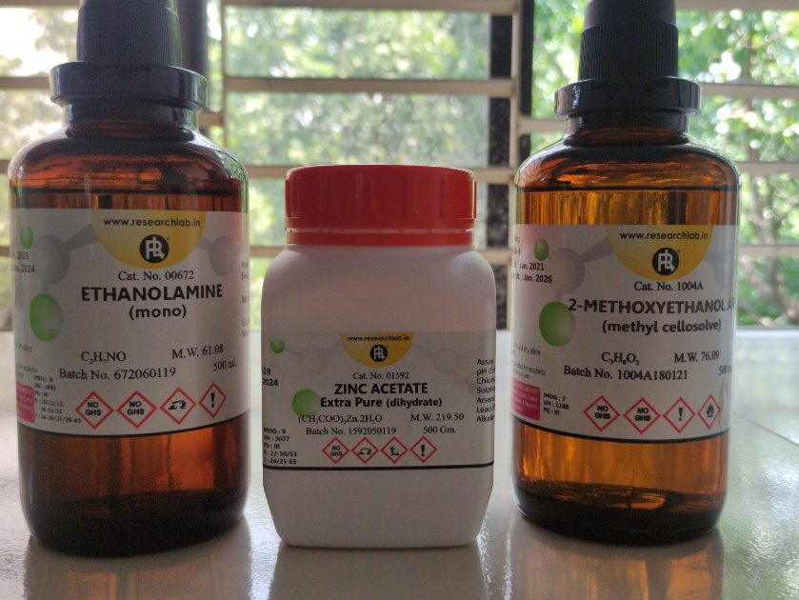

**Fig 4.1:** Raw chemical reagents

* **Starting Materials:**
* Zinc acetate dehydrate (ZAD)[𝑍𝑛 (𝐶𝐻3𝐶𝑂𝑂𝐻)2.2𝐻2O]
* Molecular weight 219.49 gm/mol



**Figure 4.2**: Starting Material (Zinc Acetate Dehydrate)

* **Solvent**
* 2-methoxy ethanol (MOE) (𝐶𝐻3𝑂𝐶𝐻2𝐶𝐻2OH)
* **Stabilizer**
* Mono-ethanol-amine (MEA) [(𝐻𝑂𝐶𝐻2𝐶𝐻2)𝑁𝐻2]
* Molecular weight 61.08 gm/mol
* Density 1.015 gm/cc



**Figure 4.3 :** Solvent and Stabilizer (2-methoxy ethanol & Mono-ethanol-amine)

**4.1.2 Doping Material**

* **Yttrium Nitrate Hexahydrate (**Y(NO3)3·6H2O)
* Molecular weight 383.01 g/mol

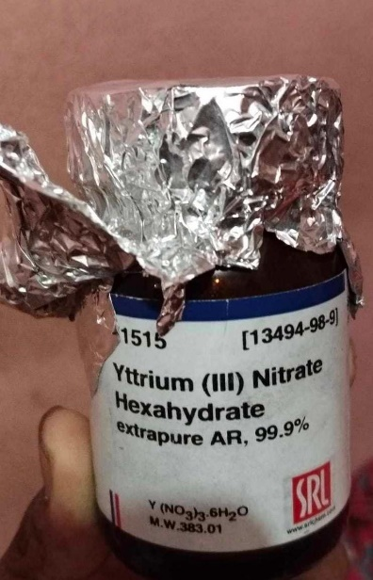

**Figure 4.4:** Doping material (Yttrium)

**4.1.3 Other ingredients**

* Glass (75mm*25mm*1mm)
* Glass cutter
* Washing agent:
* Acetone
* Ethanol
* De-ionized water
* Beaker (200 ml-2 ,500 ml -1)
* Magnetic stirrer
* Hot plate
* Ultrasonic cleaner
* Thermometer
* Micro-pipet





**(a)**

**(b)**

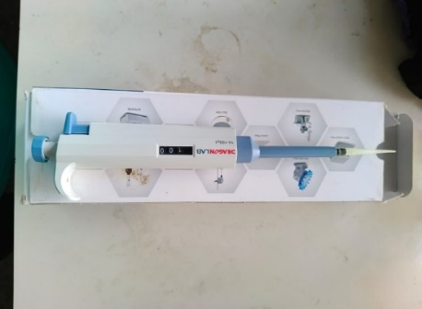

**(c)**

**(d)**

**Figure 4.5:** (a) Ultrasonic Cleaner (b) Hot Plate (c) Micro-pipet and (d) Glass Cutter

**4.2 Requirements of Raw Material**

|  |  |  |  |
| --- | --- | --- | --- |
| Composition | Raw Materials | Amount(gm) | Total(gm) |
| Pure ZnO film | (CH3COO)2Zn.2H2O | 1.75592 | 1.75592 |
| 1% YZO | (CH3COO)2Zn.2H2O | 1.73836 | 1.77404 |
| Y(NO3)3·6H2O | 0.03568 |
| 3% YZO | (CH3COO)2Zn.2H2O | 1.70324 | 1.81136 |
| Y(NO3)3·6H2O | 0.10812 |
| 5% YZO | (CH3COO)2Zn.2H2O | 1.66812 | 1.84832 |
| Y(NO3)3·6H2O | 0.18020 |

**Table 4.1**: Requirements of materials for pure and doped ZnO precursor

ZAD=0.4M

ZAD and MEA molar ratio= 1:1

**4.3 Solution Preparation**

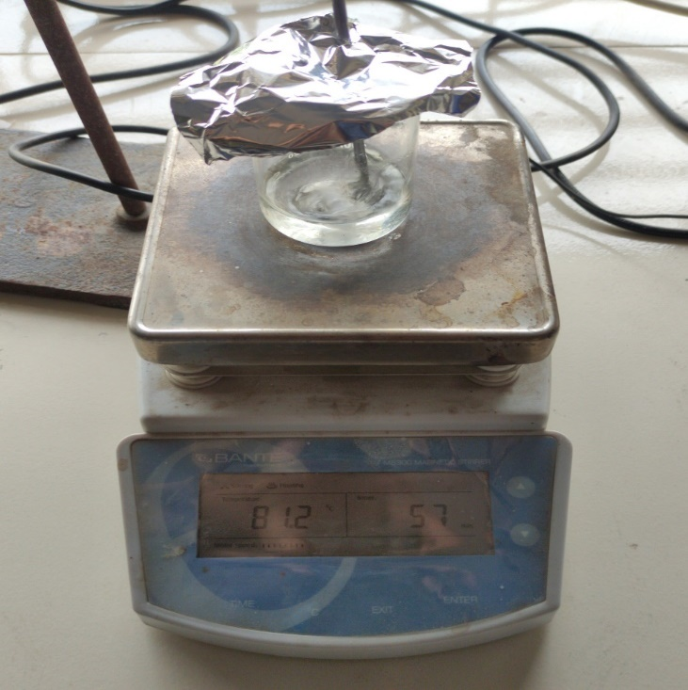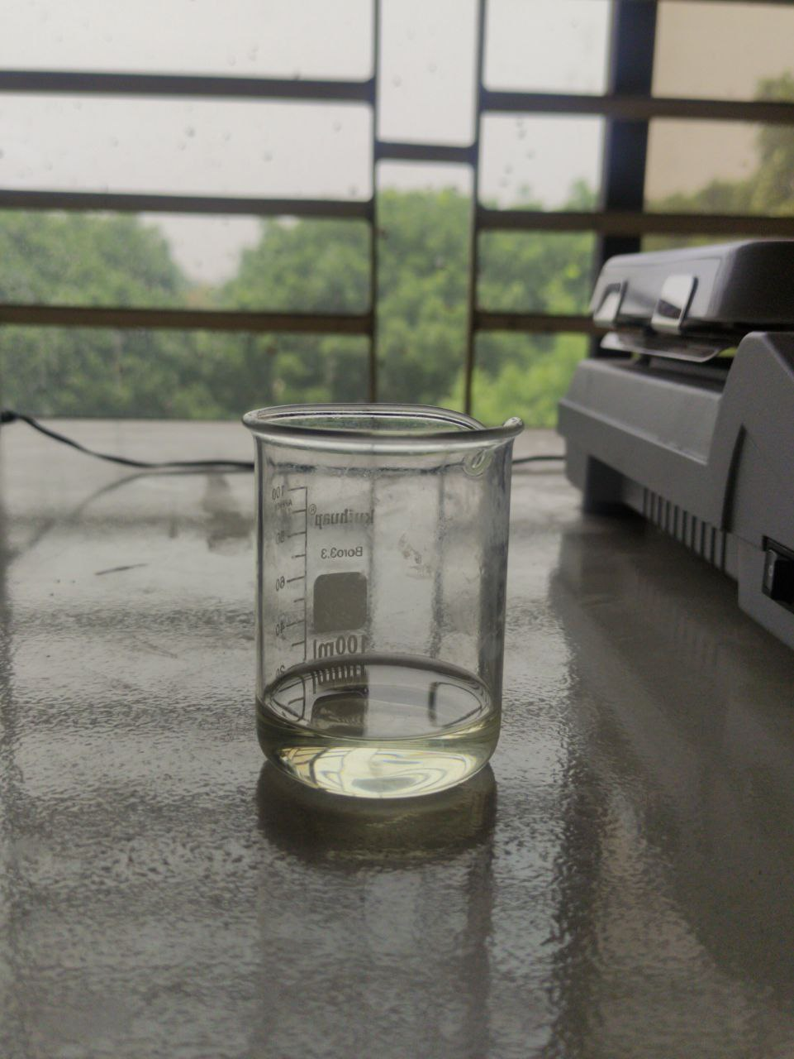

**(a)**

**(b)**

**Figure 4.6**: (a) Initial Solution (precursor) and

(b) Solution stirring for 1 hour

**4.3.1 Steps in detail:**

**Weighting:**

* Weighting should be as perfect as possible
* Before weighing, spoons should be washed with de-ionized and acetone
* The powders should be weighted just before experiment, otherwise contamination can be occurred.

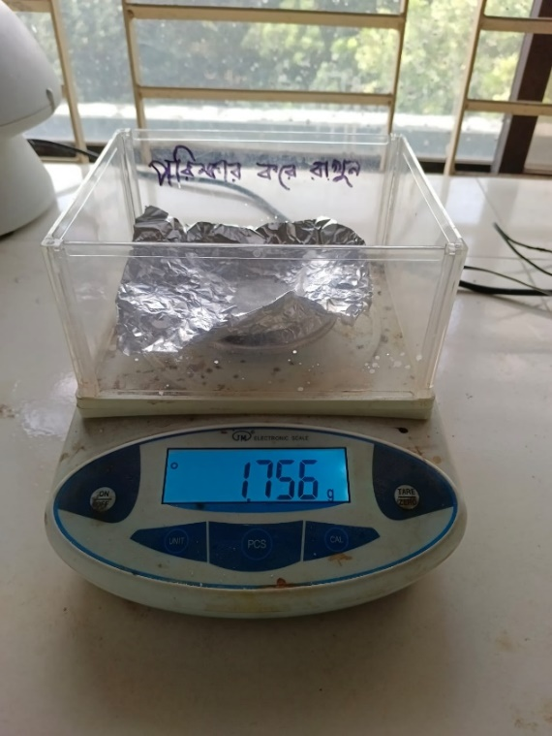

**Figure 4.7 :** Weighting Procedure

**Mixing:**

* At first solvent was added in a washed beaker (Beaker is also washed with de-ionized and acetone)
* Then starting materials and doping material were added.
* Finally, stabilizer was added.

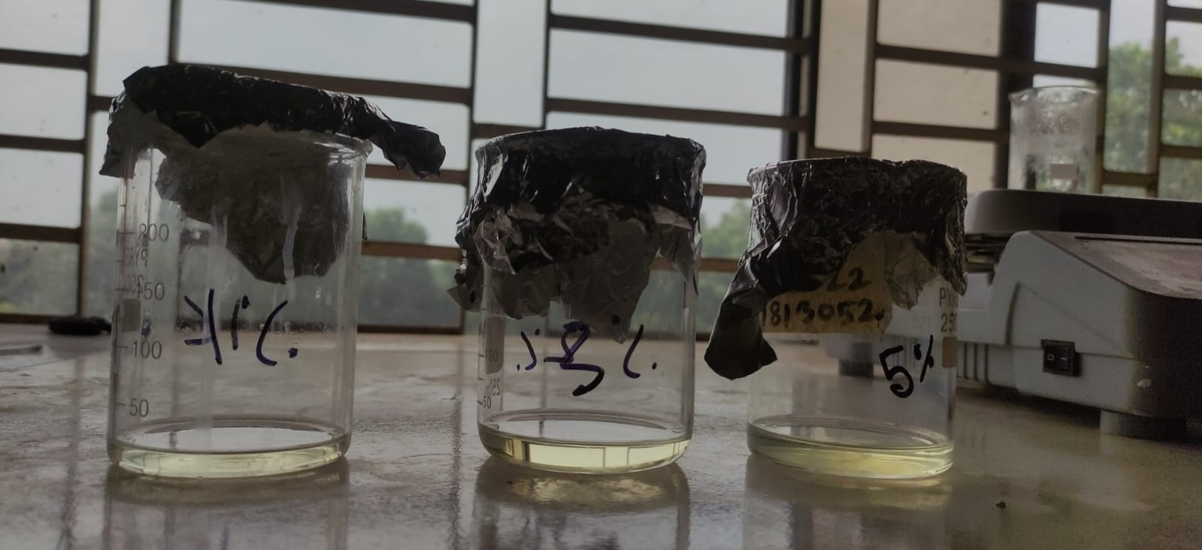

**Figure 4.8:** Solution After Mixing (1% YZO, 3% YZO, and 5% YZO)

**Stirring:**

* Stirring was done at 400 rpm at 80° C.
* As our solution quantity was small, we used a small sized magnetic stirrer.
* Temperature control was very important. Thermometer was used for this. When hot plate indicated 115° C, thermometer indicates 80° C.
* After when thermometer indicates 80° C, time counting was started.
* After 1 hour stirring, the solution was covered with aluminum foil and kept for aging for 24 hours.

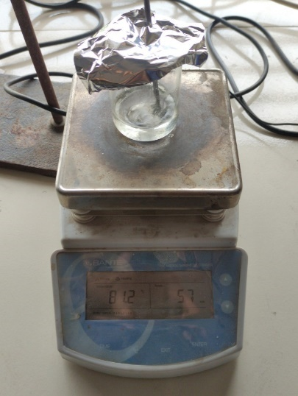

**Figure 4.9:** Solution stirring for 1 hour

**Possible chemical reactions**

(CH3COO)2Zn.2H2O + H2O ZnO + CO2 (g) + CH4 (g) + steam (g)

**4.4 Glass Preparation**

* Glass was prepared by cleaning with acetone, ethanol, de-ionized water by cotton. Ultra-sonification with de-ionized water, ethanol, acetone.
* At first silica glass was cut in appropriate size by glass cutter.
* Then the glass was brushed with detergents and washed with water.
* Then the glass was ultrasonified with de-ionized water for 5 min.
* After that the glass was ultrasonified with ethanol, acetone and again de-ionized water, each one is for 5 min
* After each drying stage the glass substrate was dried using hotplate.
* Then the glass substrate was ready for coating.
* 60% efficiency of producing uniform film depends on glass cleaning properly.

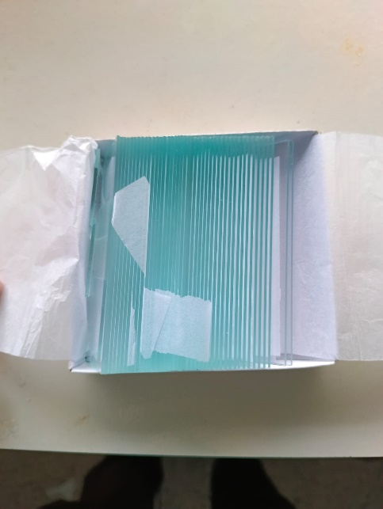

**(b)**

**(a)**



**(c)**

**Figure 4.10:** (a) Glass Slide; (b) Glass Slide After Cutting and (c) Dipped in distilled water, ethanol and acetone

**4.5 Spin coating**

* At first static coating technique was applied. But unfortunately, film quality was not good. Film was not uniform. Then dynamic spin coating technique was applied. Speed was modified experimentally.
* Solution was given using 1ml pipette. Spin coater speed was modified at1000 rpm for 10 second, then 3000 rpm for 20 sec. At first speed was low because the solution was given. To reduce scattering of the solution. Spin coater should be covered with aluminium foil.
* Glass substrate was kept at the right place. Vacuum on was done by switching.



**Figure 4.11:** Spin Coater

* Then on button was pressed and 0.05 ml solution is given on the substrate.
* After 30 seconds rotating would be stopped. Then we have to off vacuum.
* After drying, second layer was given.

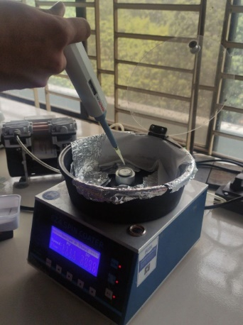

**Figure 4.12:** Spin coating process

**4.6 Drying**

After spin coating, drying for 5 min at 200 ℃. At first this step was done using furnace. But there is a great chance of contamination with the furnace atmosphere. And it was really uncomfortable. Then we started drying in the hot plate.

* At first hot plate temperature was fixed at 200℃.
* After each coating step the glass substrate was taken to hot plate.
* 5 min is the drying period.
* After drying, the sample was cooled and readied for the 2nd layer.

**4.7 Annealing**

* For annealing the thin film Protherm furnace was used. It took little time about 1 hour and 20 minutes to reach 500° C. Then 2 hour holding period and after that furnace cooling.
* Masking tape was used for making a step for measuring thickness with profilometer. But the masking tape was vaporized during high temperature annealing. Thus, film contamination occurred. For recovering that problem,
* we used at first better quality masking tape. After drying stage, the masking tape was removed as it cannot withstand the high temperature of annealing.



**Figure 4.13:** Annealing graph

**Figure 4.14:** Placing samples for annealing

**Chapter 5**

**RESULT AND DISCUSSION**

Undoped zinc oxide (ZnO) and yttrium-doped zinc oxide (Y-doped ZnO) characterization results offer important new information about the structural, optical, and electrical properties of materials. To comprehend the effect of yttrium doping on the characteristics of ZnO, these characterizations are frequently carried out utilizing a variety of analytical techniques.

**5.1 XRD Analysis**

The impact of Y doping on the crystal structure and phase transitions of the ZnO host matrix was examined using XRD analysis. The diffractograms of the various ZnO thin films created using the sol gel process are shown in Figure 1a.

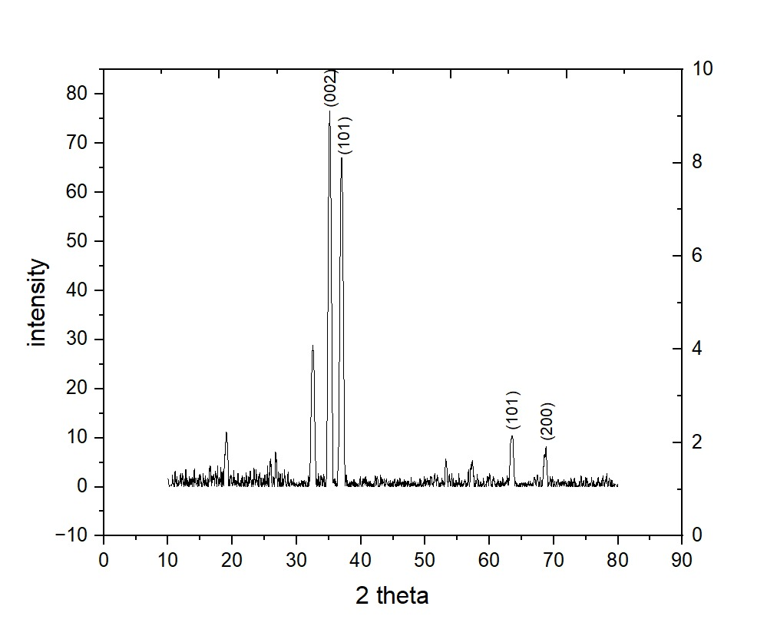

**Figure 5.1 :** XRD graph of pure ZnO thin film sample.

In this figure of XRD result, we can observe that, the most preferential crystal growth is along the (002) plane, which is an expected result for the ZnO wurtzite structure. In addition, (101) and (201) are also expected for this crystal structure. A little amount of impurities also seen in this peak results, so some other peaks also found here.

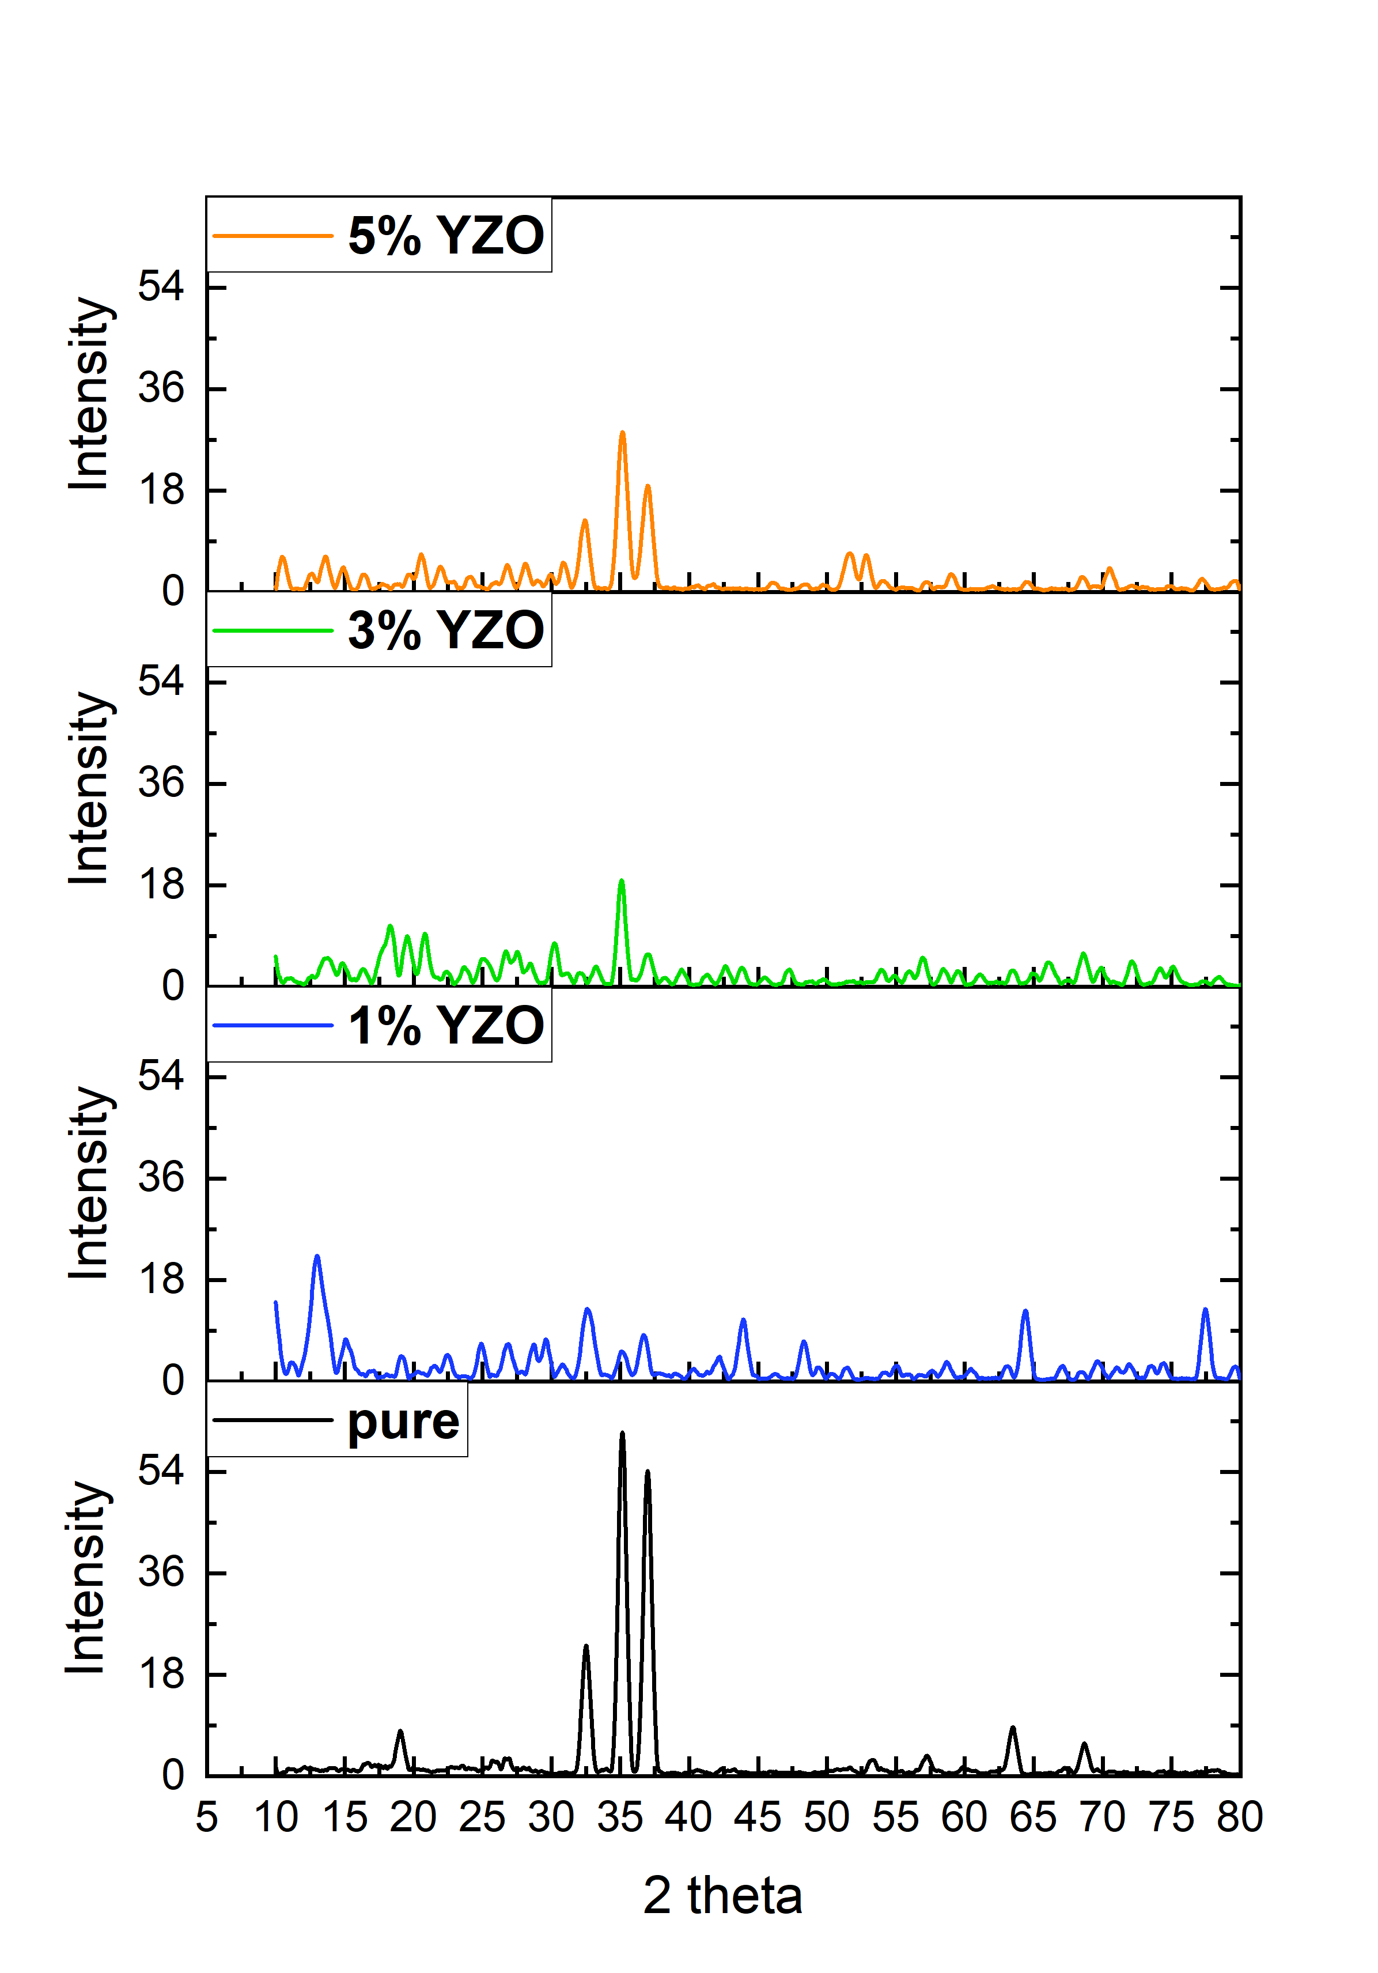

Figure 5.2: XRD graphs of all samples (pure ZnO, 1% YZO, 3% YZO, and 5% YZO) thin film samples.

Here, in the stacks, comparisons between peaks of pure, 1% YZO, 3% YZO, and 5% YZO are shown. In the 1% YZO peaks, it is observed that, there are high amounts of impurities in the material, so a lot of extra peaks are showing in the XRD figure of 1% YZO thin film. But the 3% YZO, and 5% YZO thin films have better peaks rather than the 1% YZO.

Here, the intensity of the peak is low in the Yttrium doped ZnO thin films. The 1% YZO showing low peak intensity, the 3% YZO showing lower peak than the 1%, but the 5% showing more intensity than the other two YZO films. So, it is also clear that, by doping the crystallinity is decreased.

The observed Bragg angles in our YZO films are less than those in bulk ZnO (2θBragg = 34.42°), and the 2θBragg of YZO declines with increasing Y concentration. This results from Y3+'s (0.92 Å) greater ionic radius compared to Zn2+ (0.74Å) [70]. The inclusion of bigger ionic dopants modifies the film's residual stress (σ) and lattice constant (c).

Using the Bragg equation [71], the interplanar spacing dhkl values of ZnO:Y thin films were determined:

2dhkl sinθ = nλ ----------------(1)

The lattice parameters for all the films were estimated from d values observed from d-values, according to the following equation [72]:

$\frac{1}{{d_{hkl}}^{2}}=\frac{4}{3}\left(\frac{h^{2}+k^{2}+hk}{{3a}^{2}}\right)+\frac{1}{c^{2}}$--------------------(2)

Using the Debye-Scherrer's formula [73], the size of the crystallites of pure and Y doped ZnO was calculated based on the broadening of the preferential orientation (002).

$D=\frac{kλ}{βcosθ}$---------------------------(3)

Where k stands for the form factor, is the X-ray wavelength, is the Bragg's angle of the X-ray diffraction peak, and is the full width at half maximum in radians of (002) orientation. Table 5.2 lists the values of crystallite size for the various samples.

Microstrain ɛ for each film was also determined by using the tangent formula [74]:

$ɛ=\frac{β}{4tanθ}$-------------------(4)

In the result, from the values of this table, the microstrain is given. From the given value, it is observed that in 1% YZO microstrain increased, then reduced in 3% YZO, and again increased in the 5% YZO.

From the structural analysis, it is obtained that, Y has been successfully doped within the ZnO thin film, although there are several impurities are seen due to environmental issues.

**5.2 Morphological properties**

**5.2.1 SEM**

Surface morphological studies of the un-doped/Pure ZnO and doped with 1%Y(Yttrium), 3%Y and 5%Y ZnO thin films have been carried out from scanning electron micrographs (SEM). . Figures 5.3 (a-d) shows the SEM images of all the un-doped and doped ZnO thin films.

Figure 5.3 shows SEM images of the spin - coated YZO thin films (Y: 1 , 3 and 5 at.%). The films are composed of YZO grains with the average diameter of a few tens of nanometer. As the Y contents increase up to Y = 3 at. %, the mean grain size is increased. For the YZO thin film with Y of 3 at.%, the grains are closely packed, and the surface seems to be most uniform among the samples. The thickness of the YZO films is increased as the Y concentration increases .The increase of the film thickness is attributed to the higher viscosity of the thin films that contains a larger mole fraction of Y[70].

E:\THESIS 2023\Maruf\S2103.tif E:\THESIS 2023\Maruf\S1100.tif

1. (b)

E:\THESIS 2023\Maruf\S4112.tifE:\THESIS 2023\Maruf\S3109.tif

(c) (d)

**Figure 5.3:** Scanning Electron micrographs (SEM) of (a) Pure ZnO (150KX), (b) 1%Y doped ZnO(150KX), (c) 3%Y doped ZnO (150KX) and (d) 5%Y doped ZnO (150KX).

In figure 5.3 demonstrates the SEM micrograph of ZnO nanostructured thin film and the film exhibits a porous nanostructure and the spherical crystalline particle size is approximately 40 nm. In the literature, ZnO nanostructures having 9–250 nm have been reported [71, 72].

At room temperature, the FE-SEM micrographs demonstrate the predominance of hexagonal-shaped ZnO crystals. FE-SEM micrographs reveal that the size of the crystallites assembled into the synthesized films falls within the nanometer range size. Absence of cracks is observed on large areas of all films. The ZnO film image reveals a very homogeneous distribution of connected nanoparticles over the surface, mostly hexagonal in shape, but with a small fraction of spheroid or rod-like ones. The film grown with a [Y]/ [Zn] ratio exhibits a dense surface structure composed of crystallites in the hexagonal form, in good agreement with the X-ray diffraction results.

On the other hand, it is evident that the porous structure and visibly lower homogeneity in morphology occurred throughout the film formulated with 5 at.% of Y. Based on FE-SEM images, the particle size distribution of all the samples, have close values that are observed for the intermediate doping levels, whereas lower particle sizes are measured for the un-doped and 5 at.% at Y samples. Two factors can contribute to this difference. First, SEM measures particle size, whereas XRD provides values of crystallite size. Since XRD data correspond to volume averaged values and SEM data to a linear average, the difference found in this case suggests that in all the samples, particularly in the 3at.% and 5 at.% Y, particles consist of crystalline aggregates, i.e. particles are not mono-crystalline [73].

Another question that could contribute to this difference could be the eventual anisotropy in particle shape, since measurements in the SEM images are performed in a direction parallel to the film surface and XRD provides a size which takes into account different directions. These differences have been also found in Y -doped ZnO films prepared by spray pyrolysis [74].

To check the chemical composition of the film, an energy dispersive X-ray (EDX) spectroscopy analysis was performed.

**5.2.2 EDS**

The energy dispersive X-ray spectroscopy (EDX) of un-doped/pure and Y-doped ZnO films is shown in Fig. 5.4. The spectrum confirms presence of Zn, O and Y elements in the prepared films with their nominal percentage.

Fig. 5.4 shows the EDX spectrum of ZnO nanostructured thin film. Five peaks have been clearly observed from the spectrum, which are identified as zinc, oxygen, silicon and calcium. The presence of the calcium and silicon peak in the spectrum is due to the glass substrate. It was observed that the film is only composed of zinc and oxygen.

Hence, **Yttrium is a highly crystalline iron-gray, rare-earth metal.**

In order to confirm the presence of Y3+, energy dispersion spectrum (EDS) analysis of YZO is shown in Fig. 5.4.

This structural study points out that the incorporation of Y improves the structural quality of sprayed ZnO thin films, by increasing the crystallite size (D) while decreasing the micro-strain [73]. The chemical composition of ZnO:Y films was confirmed by energy dispersive X-ray spectroscopy (XEDS). The XEDS spectra, Figure 3, reveal the presence of the expected elements Y, Zn and O in the solid films. Quantification of these spectra indicates percentages of Y close to the nominal values [73].

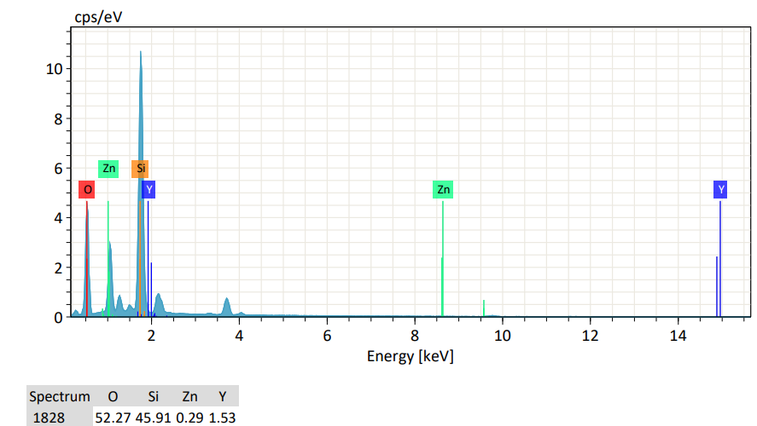 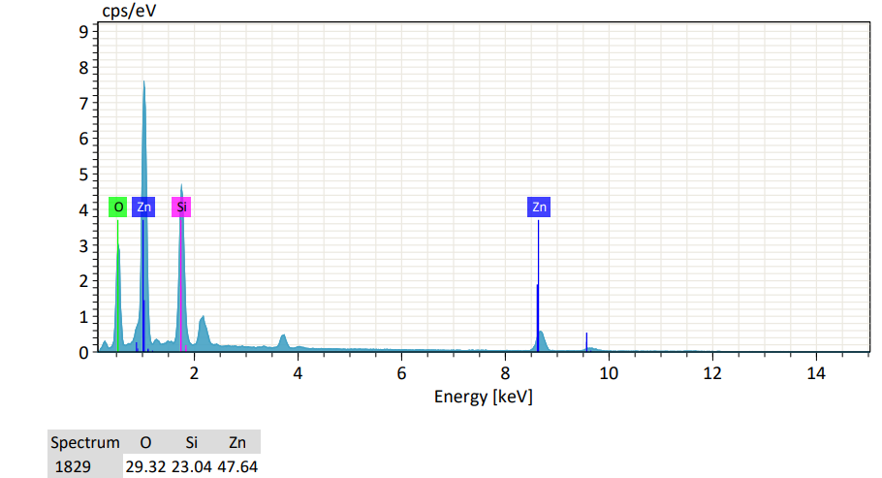

**Zn**

**Y**

**Zn**

**Y**

**Si**

**Zn**

**O**

**Si**

**Zn**

1. pure ZnO
2. 1%Y doped

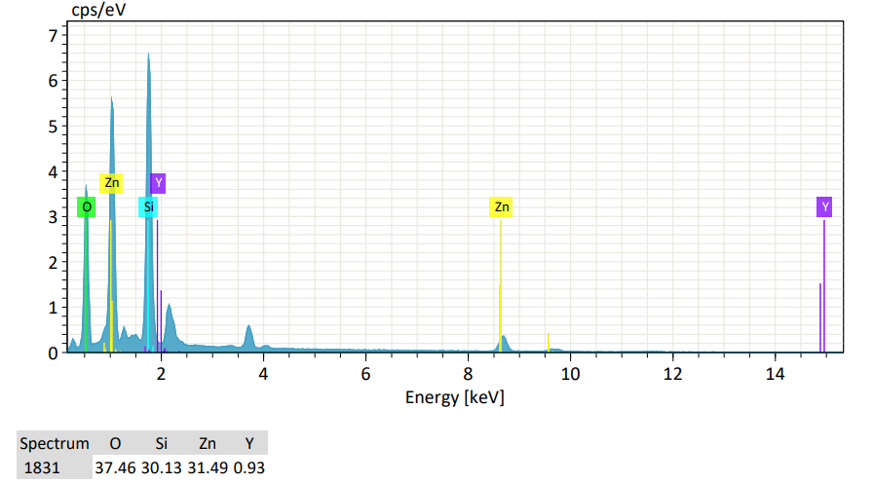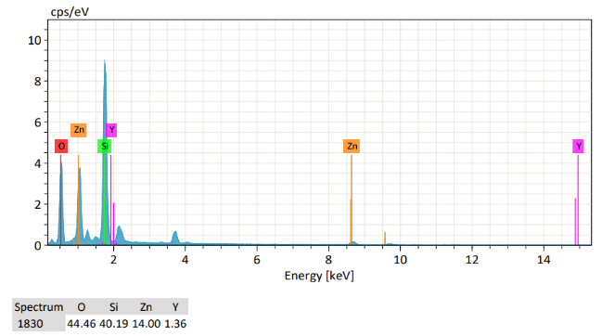

**Zn**

**Y**

**O**

**Si**

**Zn**

**O**

**Zn**

**Si**

**Y**

**Zn**

**Y**

1. 5%Y doped
2. 3% Y doped

Fig. 5.4: EDX spectrum of pure ZnO and ZnO:Y thin films [72].

**5.3 Optical properties**

**5.3.1 UV -vis. results**

Regarding optical properties, both absorbance and transmittance spectra in the UV-VIS range have been measured. The absorbance versus energy plot is as follows:

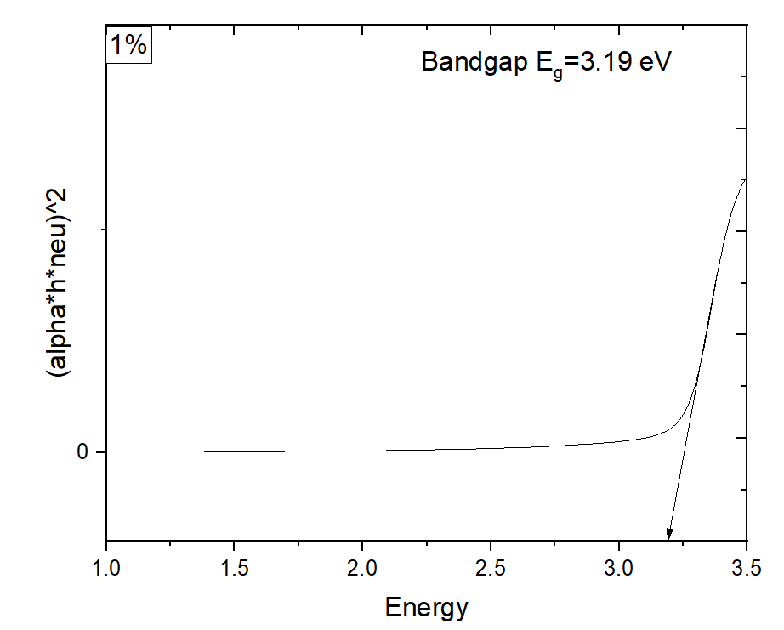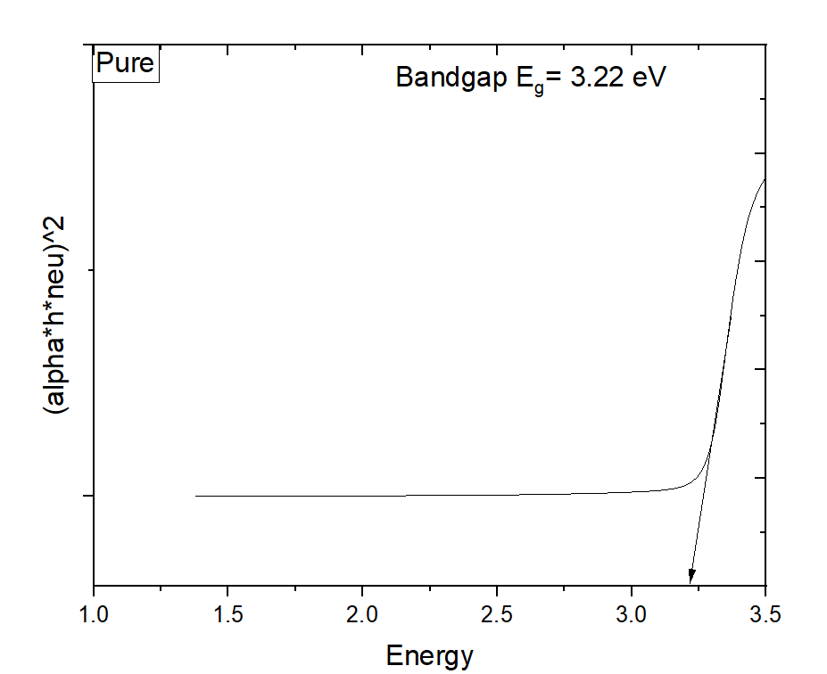

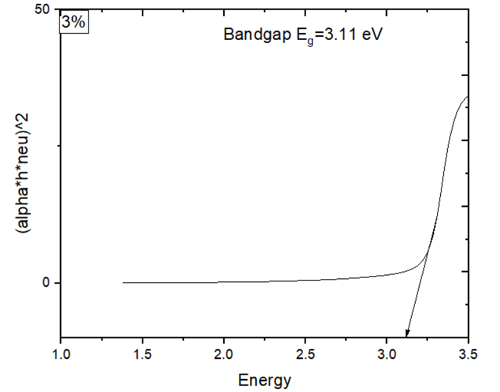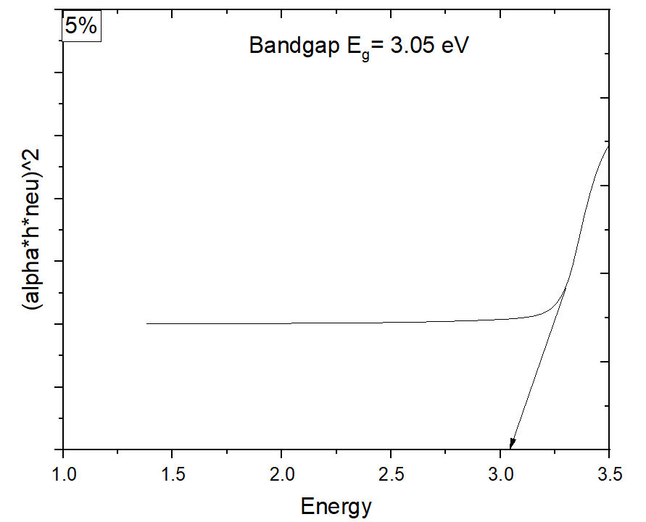

Figure 5.5: Plot of (𝛼ℎ𝜐) 2 versus incident photon energy (h𝜐) for (a) Pure ZnO, (b)1%Y doped , (c) 3% Y doped and (d) 5 % Y doped films.

The variations of (αhν) 2 with the photon energy hν in the fundamental absorption region are plotted in Fig. 5.5.The optical band gaps of the films are calculated from the absorbtion spectra employing Tauc’s plot as shown in Fig. 5.5. The absorption coefficient (α) is calculated using the equation [76],

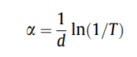

where, T is transmittance and d is film thickness. The absorption coefficient (α) and the incident photon energy (hm) is related by the following equation [76],

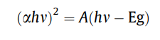

where A and Eg are constant and optical band gap respectively. Fig.5.5 shows the plots of (αhν) 2 = *f* (hν - Eg ) for pure and ZnO:Y thin films. The optical band gap value can be determined by extrapolation of the straight line at α=0. The obtained values of optical band gap energy of ZnO:Y as a function of Y concentration are reported in table 1 ,[73]. In Fig. 5.5 the absorption spectra of the different films in the wavelength range 300-900 nm, respectively.The obtained band gap values were plotted as function of Y concentrations is shown in Fig. 5.5. It can be seen that the band gap of ZnO thin films is decreased from 3.22 to 3.05 eV. The blue shift in band gap is arises because the Fermi level lies inside the conduction band for n-type doping, which related to Mass–Burstein effect [77]. A similar result was reported in the previous literature for Y-doped ZnO nano particles [78].

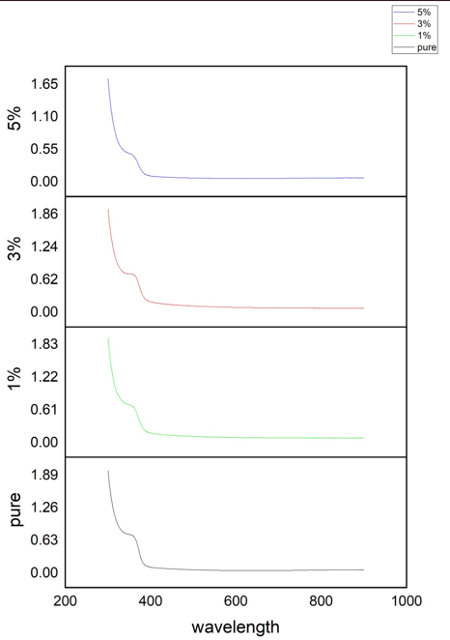

Figure 5.6: UV-vis absorption spectrum of Pure ZnO and Yttrium doped at 1%,3% and 5% with ZnO.

Typically, the percentage absorbance versus wavelength curve for yttrium-doped zinc oxide (YZO) thin films would display how the substance absorbs light at various wavelengths over the UV-visible range. The dopant concentration, film thickness, and crystal structure are only a few examples of the variables that could affect the curve's precise shape and characteristics.

You would need to conduct UV-visible spectroscopy measurements on the substance using a spectrophotometer or UV-visible spectrometer in order to produce an accurate% absorbance versus wavelength curve for your particular YZO thin film. The resulting curve can be used to describe the film's behavior in the UV-visible range and would offer useful information about its optical characteristics.

The band gap energy Eg value was found to decrease from 3.22 eV to 3.05 eV by increasing the doping content 1, 3 and 5 at.%. This shift towards higher energies could be explained by the differences in the lattice parameters or the increase of the carrier concentration (Burstein–Moss effect) [79,80].

The shift towards lower energies for the higher doping levels could be attributed to the apparition of energy states in the forbidden band close to the band edges [73].

When compared to pure ZnO, the optical band gap for 1, 3 and 5 at % , the thin films dramatically decreased (Eg = 3.22, 3.19, 3.11 and 3.05 eV, respectively). When the optical band gap reduced with Yttrium doping, the concentration of n- type carriers in the ZnO structure increased. [81,82,83] By increasing the concentration of n- type carriers through doping, the band gap is reduced and the absorption edge occurs at considerably higher wavelengths than in intrinsic materials. This is the well-known as Burstein–Moss effect.

Extrapolation of linear portion to the energy axis at (αhν)2= 0 gives the Eg value. The band gap of ZnO thin films was decreased from 3.22 eV for the un-doped films to 3.05 eV for Yttrium doping [84].

The band gap of yttrium-doped ZnO thin films is lower than the un-doped thin films, which may be explained by the Burstein - Moss shift [85]. That is, the Fermi level was lifted into the conduction band of the degenerated semiconductor when ZnO thin films were doped with yttrium, which leads to the energy band coarsening (blue shift) effect.

**CHAPTER 6**

**CONCLUSIONS & RECOMMENDATIONS**

**6.1 Conclusions:**

The following are the conclusions drawn from the present investigation:

An efficient and easy synthesis process was essential to go forward with the work. Spin coating is an ideal approach for film deposition to tackle the difficulty since the thin film is created from a precursor solution that is totally dissolved (the solute dissolves completely in the solvent).

YZO films were prepared on p-Si (glass) substrates by the sol–gel spin coating method. Due to the low ionization energy of Y, high quality YZO films were obtained despite of the low temperature growth process. The samples displayed the solution limit of Y dopants for 1,3 and 5 at.%, and the YZO film **with Y = 5 at.% revealed the lowest electrical resistivity among our samples.** The decreased electrical resistivity was confirmed to originate from both the decreased density of positively-charged native-point-defects and the increased crystallite size of YZO. The incorporation of an appropriate concentration of Y helps improve the structural and the electrical properties of YZO.

Pure and Y-doped ZnO were successfully deposited on a glass-preheated substrate at 500 0C by a spin coating method. The influence of incorporation of Y on structural, morphological and optical properties of ZnO crystal lattice was investigated. So, transparent conducting Yttrium-doped ZnO thin films were prepared by sol -gel spin coating method.

**The study's key conclusions can be summarized as follows:**

* The X-ray diffraction spectrum was indicated that the film has the polycrystalline in nature with a hexagonal wurtzite structure. The optical band gap and optical constants (refractive index, absorption coefficient, real and imaginary parts of the dielectric constant) of ZnO nanostructured thin film were determined. The films deposited at the first post-heat treatment temperature showed preferred ZnO (002) orientation, while the intensity of a (002) peak increased with an increase in the annealing temperature. Surface morphologies of the 1 at.% Yttrium-doped ZnO thin films showed a particulate and porous structure. The energy band gap of ZnO thin films calculated from the absorption spectra is about 3.05-3.22 eV.
* SEM images of the films showed different micro-structures with nano-clusters and illustrate that all the films exhibit a dense surface structure with a hexagonal shape grains. The calculated structural parameters evidence that the incorporation of Y entails a decrease in the micro-strain, which demonstrates that doping with Y3+ ions actually improve the quality of the as-deposited films . The surface was strongly influenced by Y doping with ZnO films and observed a reduction in surface roughness.
* The UV-visible study showed that all the films are highly transparent in the visible domain.
* The EDX spectrums confirmed the presence of Zn, O and Y elements in the prepared films.

We observed an improvement in optical transmittance (by UV Vis. spectra) for Y-doped ZnO thin films in visible region . The optical band gap of films shows a blue shift with Y doping. The diminishing photoluminescence peak intensity and observed blue shift of UV emissions peak is revealed that substitutions Y into ZnO systems. The presence of functional groups and chemical bonding may be confirmed by FTIR. The Hall measurements show that improvements in electrical properties and films have n-type conductivity.

The results of structural characterization indicate that Y ions are incorporated into ZnO crystal lattices. With increasing Y doping concentration, the intensity of UV emission can be strongly enhanced and the peak position with maximum intensity in deep -level emission band can be gradually tuned from 539 nm to 598 nm (by XRD results) since the Y doping has redistributed the defects in the YZO nanoparticles. This obvious modulation of deep-level emission is incontrovertibly prompting the application of ZnO nanoparticles in full-color displays and photoelectric nano-devices.

The growth technique also can be applied to introduce other rare-earth elements (besides Y) into ZnO nanoparticles with great advantages of easy operation and low cost. The UV emission performance confirms that ZnO:Y system offer potential applications in optoelectronic devices.

So, the Y doped-ZnO thin films are used as a potential candidate for optoelectronic applications.

**6.2 Recommendations:**

This can be taken into account the following suggestions to improve the qualities of yttrium-doped zinc oxide (YZO) thin films created using the spin-coating method:

1. Preparing a Precursor Solution: To assure purity in the precursor solution, It can be started with top-notch raw ingredients. To achieve the necessary characteristics without creating flaws or significant lattice deformation, optimize the concentration of Yttrium dopant.
2. Controlling film thickness: To obtain the appropriate film thickness, It should be adjusted the spin-coating parameters (spin speed, spin time). For thicker films, further coatings with annealing stages in between might be required.
3. Prepare the substrate: Before deposition, It should be make sure the substrate is cleaned and free of impurities .If necessary, alter the substrate surface to promote crystal development and adherence, for instance by applying suitable surface treatments like UV-ozone or plasma cleaning.
4. Spin-Coating Conditions: To ensure consistent film deposition, optimize the spin-coating parameters (such as spin speed and duration). Find the perfect parameters for your YZO thin films by experimenting with various variables.
5. Annealing and drying: Their should be used controlled annealing and drying procedures to drive crystallization and eliminate solvents.To determine the parameters that result in the optimal film characteristics, experiment with various annealing temperatures and times. It should be avoided temperatures that are too high since that might lead to dopant segregation or deterioration.
6. Incorporating dopants: It should be make sure the Yttrium dopants are distributed uniformly throughout the film. To avoid segregation, this should be needed to stir or sonicate the precursor solution. To maximize the electrical and optical qualities while reducing flaws, controlled the doping concentration.
7. After annealing in a controlled environment: To customize the film's electrical and optical properties, their required to conduct post-annealing in a regulated environment (such as oxygen or nitrogen).

While nitrogen annealing might be decreased oxygen vacancies, oxygen annealing can increase carrier concentration and transparency.

1. Characterization: Their should be analyzed the quality and performance of the YZO thin films utilizing methods such as X-ray diffraction (XRD), scanning electron microscopy (SEM), and electrical and optical testing.
2. Coating and annealing once more: In order to enhance film quality and thickness uniformity, It should be thought about doing several deposition and annealing cycles.
3. Co-doping and additives: The properties of the YZO thin films could be further customized to match the needs of a particular application by experimenting with additions or co-doping with other elements.
4. Employing surfactants: Surfactants could sometimes be added to the precursor solution to help with film uniformity and fault reduction.
5. Improve the YZO ratio: For the particular application, It should be adjusted with the Yttrium-to-zinc ratio in the precursor solution to fine-tune the film's characteristics and maximize its performance.

Eventually, It should be kept in mind that finding the ideal spin-coating conditions for the specific application might be necessitated iterative experimentation and spin-coating process and post-processing step optimization.

**CHAPTER 7**

**References**

1. X. Fang, J. Li, D. Zhao, D. Shen, B. Li, X. Wang, J. Phys. Chem. C 113 (2009) 21208.

2. T. Jun, K. Song, Y. Jung, S. Jeong, J. Moon, J. Mater. Chem. 21 (2011) 13524.

3. C.-T. Wu, J.-J. Wu, J. Mater. Chem. 21 (2011) 13605.

4. L. Znaidi, Mater. Sci. Eng. B 174 (2010) 18.

5. X. Han, K. Han, M. Tao, Low Resistivity Yttrium-Doped Zinc Oxide by Electrochemical Deposition, J. Electrochem. Soc. 157 (2010) H593. doi:10.1149/1.3377092.

6. R. Kaur, A. V. Singh, R.M. Mehra, Structural, electrical and optical properties of sol-gel derived yttrium doped ZnO films, Phys. Status Solidi. 202 (2005) 1053– 1059. doi:10.1002/pssa.200420006.

7. X.B. Li, Q.Q. Zhang, S.Y. Ma, G.X. Wan, F.M. Li, X.L. Xu, Microstructure optimization and gas sensing improvement of ZnO spherical structure through yttrium doping, Sensors Actuators, B Chem. 195 (2014) 526–533. doi:10.1016/j.snb.2014.01.087.

8. J. Yang, R.Wang, L. Yang, J. Lang,M.Wei, M. Gao, X. Liu, J. Cao, X. Li, N. Yang, J. Alloys Compd. 509 (2011) 3606.

9. X. Han, K. Han, M. Tao, J. Electrochem. Soc. 157 (2010) H593.

10. P.-T. Hsieh, R.W.-K. Chuang, C.-Q. Chang, C.-M. Wang, S.-J. Chang, J. Sol-Gel Sci. Technol. 58 (2011) 42.

11. P. Chen, W. Lai, L.-C. Peng, C. Kuo, C.-L. Yeh, J. Sheu, C. Tun, IEEE Trans. Electron Devices 57 (2010) 134.

12. X. Han, K. Han, M. Tao, Low Resistivity Yttrium-Doped Zinc Oxide by Electrochemical Deposition, J. Electrochem. Soc. 157 (2010) H593. doi:10.1149/1.3377092.

13. P.-T. Hsieh, R.W.-K. Chuang, C.-Q. Chang, C.-M. Wang, S.-J. Chang, Optical and structural characteristics of yttrium doped ZnO films using sol–gel technology, J. Sol-Gel Sci. Technol. 58 (2011) 42–47. doi:10.1007/s10971-010-2352-0.

14. C.J. Tun, J.K. Sheu, B.J. Pong, M.L. Lee, M.Y. Lee, C.K. Hsieh, C.C. Hu, G.C. Chi, IEEE Photon. Technol. Lett. 18 (2006) 274

15. B.N. Pawar, S.R. Jadkar, M.G. Takwale, J. Phys. Chem. Solids 66 (2005) 1779.

16. W.W. Wang, X.G. Diao, Z. Wang, M. Yang, T.M. Wang, Z. Wu, Thin Solid Films 491 (2005) 54.

17. M. Lorenz, E.M. Kaidashev, H.V. Wenchstern, V. Riede, C. Bundesmann, D. Spemann, G. Benndorf, H. Hochmuth, A. Rahm, H.C. Semmelhack, M. Grundmann,

Solid-State Electron. 47 (2003) 2205.

18. M. Gabas, N.T. Barrett, J.R. Ramos-Barrado, S. Gotac, T.C. Rojas, M.C. LopezEscalante, Sol. Energy Mater. Sol. Cells 93 (2009) 1356–1365

19. M. Yin, S. Liu, One-pot synthesis of Co-doped ZnO hierarchical aggregate and its high gas sensor performance, Mater. Chem. Phys. 149 (2015) 344–349. doi:10.1016/j.matchemphys.2014.10.027.

20. Pearton SJ, Norton DP, Ip K, Heo YW, Steiner T: Recent progress in processing and properties of ZnO. Prog Mater Sci 2005, 50:293-340.

21. O¨ zgu¨ r U, Alivov YI, Liu CA, Teke M, Reshchikov MA, Doan S, Avrutin V, Cho SJ, Morkoc¸ H: A comprehensive review of ZnO materials and devices. J Appl Phys 2005, 98 041301-1–55.

22. Pearton, S. J., & Ren, F. (2014). Advances in ZnO-based materials for light emitting diodes. Current Opinion in Chemical Engineering, 3, 51-55.

23. Carcia P F, McLean R S, Reilly M H and Nunes G 2003 Appl.Phys. Lett. 82 1117

24. Chu, S. Y., Yan, T. M., & Chen, S. L. (2000). Analysis of ZnO varistors prepared by the sol–gel method. Ceramics International, 26(7), 733-737.

25. Yu, Q., Fu, W., Yu, C., Yang, H., Wei, R., Sui, Y., ... & Zou, G. (2007). Structural, electrical and optical properties of yttrium-doped ZnO thin films prepared by sol–gel method. Journal of Physics D: Applied Physics, 40(18), 5592.

26. Zhou, Y., L. Yang, and Y. Huang, Micro-and macromechanical properties of materials. 2013: CRC Press.

27. Jagadish, C., & Pearton, S. J. (Eds.). (2011). Zinc oxide bulk, thin films and nanostructures: processing, properties, and applications. Elsevier.

28. Callister, W. D., & Rethwisch, D. G. (2007). Materials science and engineering: an introduction (Vol. 7, pp. 665-715). New York: John Wiley & Sons.

29. Olsen, V. S. (2015). Synthesis and Characterization of Homoepitaxial ZnO Thin Films (Master's thesis).

30. Stadler, A. (2012). Transparent conducting oxides—an up-to-date overview. Materials, 5(4), 661-683.

31. Liu, Y., Li, Y., & Zeng, H. (2013). ZnO-based transparent conductive thin films: doping, performance, and processing. Journal of Nanomaterials, 2013.

32. Exarhos, G. J., & Zhou, X. D. (2007). Discovery-based design of transparent conducting oxide films. Thin solid films, 515(18), 7025-7052.

33. Ayouchi, R., Leinen, D., Martın, F., Gabas, M., Dalchiele, E., & Ramos-Barrado, J. R. (2003). Preparation and characterization of transparent ZnO thin films obtained by spray pyrolysis. Thin Solid Films, 426(1-2), 68-77.

34.Xu, D., Deng, Z., Xu, Y., Xiao, J., Liang, C., Pei, Z., & Sun, C. (2005). An anode with aluminum doped on zinc oxide thin films for organic light emitting devices. Physics Letters A, 346(1-3), 148-152.

35. Minami, T. (2000). New n-type transparent conducting oxides. MRS bulletin, 25(8), 38-44.

36. Zhang, K. H., Xi, K., Blamire, M. G., & Egdell, R. G. (2016). P-type transparent conducting oxides. Journal of Physics: Condensed Matter, 28(38), 383002.

37. Mizoguchi, H., Eng, H. W., & Woodward, P. M. (2004). Probing the electronic structures of ternary perovskite and pyrochlore oxides containing Sn4+ or Sb5+. Inorganic chemistry, 43(5), 1667-1680.

38. Segev, D., & Wei, S. H. (2005). Structure-derived electronic and optical properties of transparent conducting oxides. Physical Review B, 71(12), 125129.

39. Ginley, D. S., & Bright, C. (2000). Transparent conducting oxides. MRS bulletin, 25(8), 15-18.

40. Sadewasser, S., Glatzel, T., Rusu, M., Jäger-Waldau, A., & Lux-Steiner, M. C. (2002). High-resolution work function imaging of single grains of semiconductor surfaces. Applied Physics Letters, 80(16), 2979-2981.

41. Minami, T. (2000). New n-type transparent conducting oxides. MRS bulletin, 25(8), 38- 44.

42. Gordon, R. G. (2000). Criteria for choosing transparent conductors. MRS bulletin, 25(8), 52-57.

43. Coutts, T. J., Young, D. L., Li, X., Mulligan, W. P., & Wu, X. (2000). Search for improved transparent conducting oxides: A fundamental investigation of CdO, Cd2SnO4, and Zn2SnO4. Journal of Vacuum Science & Technology A: Vacuum, Surfaces, and Films, 18(6), 2646-2660.

44. Efafi, B., Mousavi, S. S., Ara, M. H. M., Ghafari, B., & Mazandarani, H. R. (2017). A method for optimizing the electrical conductivity of Al: ZnO TCO films. Materials Letters, 195, 52-54.

45. H. Liu, V. Avrutin, N. Izyumskaya, Ü. Özgür, and H. Morkoc, “Transparent conducting oxides for electrode applications in light emitting and absorbing devices,” Superlattices Microstruct, vol. 48, no. 5, pp. 458 – 484, 2010.

46. Sahu, D. R.; Lin, S.-Y.; Huang, J.-L. ZnO/Ag/ZnO Multilayer Films for the Application of a Very Low Resistance Transparent Electrode. Appl. Surf. Sci. 2006, 252, 7509–7514

47. Idris, M. S., & Subramani, S. (2021). Nanostructures multilayer MgO/ZnO thin film thermal interface material for LED applications: Thermal, optical, and surface temperature performance. Journal of Materials Science: Materials in Electronics, 32(12), 16008-16023.

48. B. G. Streetman and S. K. Banerjee, Solid State Electronic Devices. Pearson Prentice Hall, 6 ed., 2006. 28. J. C. Fan, K. M. Sreekanth, Z. Xie, S. L. Chang, and K. V. Rao, “p-type ZnO materials: Theory, growth, properties and devices,” Progress in Materials Science, vol. 58, no. 6, pp. 874 – 985, 2013.

49. Y. Lixin, X. Zheng, H. Yanbing, Z. Xiqing, W. Yongsheng, X. Xurong, The ultraviolet and blue luminescence properties of ZnO:Zn thin films, Chin. Sci. Bull. 46 (2001) 1223.

50. Ü. Özgür, Y. I. Alivov, C. Liu, A. Teke, M. A. Reshchikov, S. Dogan, V. Avrutin, S. J. Cho, and H. Morkoc, “A comprehensive review of ZnO materials and devices,” J. Appl. Phys., vol. 98, 2005.

51. K. Momma and F. Izumi, “VESTA 3 for three-dimensional visualization of crystal, volumetric and morphology data,” J. Appl. Crystal logr., vol. 44, pp. 1272–1276, Dec 2011.

52. Cho, A., Growth of periodic structures by the molecular‐beam method. Applied Physics Letters, 1971. 19(11): p. 467-468.

53. Schmidt-Mende, L., & MacManus-Driscoll, J. L. (2007). ZnO–nanostructures, defects, and devices. Materials today, 10(5), 40-48.

54. Yamamoto, T., & Katayama-Yoshida, H. (2001). Physics and control of valence states in ZnO by codoping method. Physica B: Condensed Matter, 302, 155-162.

55. Maissel, L. I., Glang, R., “Handbook of Thin Film Technology” Mc. Graw-Hill Company, 1970.

56. Schuegraf, K. K. (1988). Handbook of thin-film deposition processes and techniques: principles, methods, equipment, and applications. Noyes Data Corporation/Noyes Publications.

57. Pung, S.-Y., et al., Preferential growth of ZnO thin films by the atomic layer deposition technique. Nanotechnology, 2008. 19(43): p. 435609.

58. Burton, W.-K., N. Cabrera, and F. Frank, The growth of crystals and the equilibrium structure of their surfaces. Philosophical Transactions of the Royal Society of London. Series A, Mathematical and Physical Sciences, 1951. 243(866): p. 299-358.

59. Dutta, K.C.P.P.V., Thin-film solar cells: an overview. Prog. Photovoltaics Res. Appl, 2004. 12(23): p. 69-92.

60. Craciun, V., et al., Characteristics of high quality ZnO thin films deposited by pulsed laser deposition. Applied physics letters, 1994. 65(23): p. 2963-2965.

61. Tvarozek, V., et al., Influence of sputtering parameters on crystalline structure of ZnO thin films. Thin Solid Films, 2007. 515(24): p. 8756-8760.

62. Kumar, R., et al., ZnO nanostructured thin films: Depositions, properties and applications—A review. Materials Express, 2015. 5(1): p. 3-23.

63. Kappertz, O., et al., Reactive sputter deposition of zinc oxide: Employing resputtering effects to tailor film properties. Thin Solid Films, 2005. 484(1-2): p. 64-67.

64. M. J. Alam and D. C. Cameron, “Preparation and properties of transparent conductive aluminum-doped zinc oxide thin films by solgel process,” Journal of Vacuum Science & Technology A, vol. 19, pp. 1642–1646, July 2001.

65. Cullity, B. D., ‘Elements of X-ray Diffraction’ Addison-Wesley Publishing Company. Inc. USA, 1959.

66. Kodom, K. (2011). Heavy metal pollution in soils from anthropogenic activities. LAP LAMBERT Academic Publishing, 120.

67. Zhu, F. Y., Wang, Q. Q., Zhang, X. S., Hu, W., Zhao, X., & Zhang, H. X. (2014). 3D nanostructure reconstruction based on the SEM imaging principle, and applications. Nanotechnology, 25(18), 185705.

68. https://www2.chemistry.msu.edu/faculty/reusch/virttxtjml/spectrpy/uv-vis/uvspec.htm

69.Service Detail. (2019). Retrieved from http://14.139.58.69/icar_teldir/services/home/service_detail?name_instru=FTIR%20Spec trophotometer%20&unique_num=150&xdidz=361&p=../institute/instrument_image&d=s ervices_inti&c=services_chargeinti&xdybz=institute_committee&qptsu=../institute/com mittee_image.

[70] Heo, S., Sharma, S. K., Lee, S., Lee, Y., Kim, C., Lee, B., ... & Kim, D. Y. (2014). Effects of Y contents on surface, structural, optical, and electrical properties for Y-doped ZnO thin films. *Thin Solid Films*, *558*, 27-30.

[71] Y.S. Kim, W.P. Tai, S.J. Shu, Thin Solid Films 491 (2005) 153.

[72] S. Mridha, D. Basak, Mater. Res. Bull. 42 (2007) 875.

[73] Bazta, O., Urbieta, A., Piqueras, J., Fernández, P., Addou, M., Calvino, J. J., & Hungría, A. B. (2019). Influence of yttrium doping on the structural, morphological and optical properties of nanostructured ZnO thin films grown by spray pyrolysis. *Ceramics International*, *45*(6), 6842-6852.

[74] L. Dghoughi, F. Ouachtari, M. Addou, B. Elidrissi, H. Erguig, A. Rmili, A. Bouaoud, The effect of Al-doping on the structural, optical, electrical and cathodoluminescence properties of ZnO thin films prepared by spray pyrolysis, Phys. B Condens. Matter. 405 (2010) 2277–2282. doi:10.1016/j.physb.2010.02.025.

[75] Caglar, M., Ilican, S., Caglar, Y., & Yakuphanoglu, F. (2009). Electrical conductivity and optical properties of ZnO nanostructured thin film. *Applied surface science*, *255*(8), 4491-4496.

[76] Anubha Jain, P. Sagar, R.M. Mehra, Band gap widening and narrowing in moderately and heavily doped n-ZnO films, SolidState Electron. 50 (2006) 1420–1424.

[77] E. Burstein, Anomalous optical absorption limit in InSb, Phys. Rev. 93 (1954) 632–701.

[78] S. Anandan, S. Muthukumaran, Influence of Yttrium on optical, structural and photoluminescence properties of ZnO nanopowders by sol–gel method, Opt. Mater. 35 (2013) 2241–2249.

[79] D. Gherouel, I. Gaied, K. Boubaker, N. Yacoubi, M. Amlouk, Some physical investigations of AgInS2-xSexthin film compounds obtained from AgInS2annealed in seleneide atmosphere, J. Alloys Compd. 545 (2012) 190–199. doi:10.1016/j.jallcom.2012.07.148.

[80] Y.M. Hao, S.Y. Lou, S.M. Zhou, R.J. Yuan, G.Y. Zhu, N. Li, Structural, optical, and magnetic studies of manganese-doped zinc oxide hierarchical microspheres by self-assembly of nanoparticles, Nanoscale Res. Lett. 7 (2012) 1–13. doi:10.1186/1556-276X-7-100.

[81] Moss, T. S. (1954). The interpretation of the properties of indium antimonide. Proceedings of the Physical Society. Section B, 67(10), 775.

[82] Sernelius, B. E., Berggren, K. F., Jin, Z. C., Hamberg, I., & Granqvist, C. G. (1988). Bandgap tailoring of ZnO by means of heavy Al doping. Physical Review B, 37(17), 10244.

[83] Mondal, S. B. S. R., Bhattacharyya, S. R., & Mitra, P. (2013). Effect of Al doping on microstructure and optical band gap of ZnO thin film synthesized by successive ion layer adsorption and reaction. Pramana, 80(2), 315-326.

[84] Yu, Q., Yang, H., Fu, W., Chang, L., Xu, J., Yu, C., ... & Zou, G. (2007). Transparent conducting yttrium-doped ZnO thin films deposited by sol–gel method. *Thin Solid Films*, *515*(7-8), 3840-3843.

[85] E. Burstein, Phys. Rev. 93 (1954) 632.

[86] J.-H. Lee, B.-O. Park, Thin Solid Films 426 (2003) 94.

[87] J.-H. Lee, K.-H. Ko, B.-O. Park, J. Cryst. Growth 247 (2003) 119.

[88] S. Major, A. Banerjee, K.L. Chopra, Thin Solid Films 122 (1984) 31.

[89] Sungeun Heo, Sanjeev K. Sharma, Sejoon Lee, Youngmin Lee, Changmin Kim, Byungho Lee, Hwangho Lee, Deuk Young Kim, Effects of Y contents on surface, structural, optical, and electrical properties for Y-doped ZnO thin films, Thin Solid Films 558 (2014) 27–30.

[90] Qingjiang Yu, Haibin Yang, Wuyou Fu, Lianxia Chang, Jing Xu, Cuiling Yu, Ronghui Wei, Kai Du, Hongyang Zhu, Minghui Li, Guangtian Zou, Transparent conducting yttrium-doped ZnO thin films deposited by sol–gel method, Thin Solid Films 515 (2007) 3840–3843.

[91] Kaur, N., & Sharma, S. K. (2016). Stress relaxation and transitions in optical bandgap of yttrium doped zinc oxide (YZO) thin films. *Current Applied Physics*, *16*(3), 231-239.

[92] Sharma, S. K., Pamidimarri, D. S., Kim, D. Y., & Na, J. G. (2015). Y-doped zinc oxide (YZO) nanoflowers, microstructural analysis and test their antibacterial activity. *Materials Science and Engineering: C*, *53*, 104-110.

[93] Kumar, P., Singh, V., Sharma, V., Rana, G., Malik, H. K., & Asokan, K. (2015). Investigation of phase segregation in yttrium doped zinc oxide. *Ceramics international*, *41*(5), 6734-6739.

[94] Thirumoorthi, M., & Prakash, J. T. J. (2015). Structural, morphological characteristics and optical properties of Y doped ZnO thin films by sol–gel spin coating method. *Superlattices and Microstructures*, *85*, 237-247.

[95] Yogamalar, R., Venkateswaran, P. S., Benzigar, M. R., Ariga, K., Vinu, A., & Bose, A. C. (2012). Dopant induced bandgap narrowing in Y-doped zinc oxide nanostructures. *Journal of nanoscience and nanotechnology*, *12*(1), 75-83.

[96] Kılınç, N., Öztürk, S., Arda, L., Altındal, A., & Öztürk, Z. Z. (2012). Structural, electrical transport and NO2 sensing properties of Y-doped ZnO thin films. *Journal of alloys and compounds*, *536*, 138-144.

**APPENDIX**

1. **XRD Results**

**Table 1:** XRD results for wurtzite ZnO for all examined samples indexed with JCPDS card number 96-101-1260.

|  |  |  |  |  |  |
| --- | --- | --- | --- | --- | --- |
| **hkl** | **2θ** | | | | |
| **ZnO Wurtzite Structure** | **Pure ZnO** | **1% YZO** | **3% YZO** | **5% YZO** |
| (002) | 34.228 |  | 34.327 | 34.411 | 34.536 |
| (100) | 31.749 | 32.138 |  | 30.248 | 31.889 |
| (101) | 36.257 | 35.903 | 36.427 |  | 36.384 |
| (102) | 47.257 |  | 48.348 |  |  |
| (110) | 56.535 |  |  | 56.841 |  |
| (200) | 63.341 | 63.846 |  |  |  |

**Table 2:** Lattice parameters analysis

|  |  |  |  |  |
| --- | --- | --- | --- | --- |
| Parameters | Sample | | | |
| Pure ZnO | 1% YZO | 3% YZO | 5% YZO |
| D (nm) | 18.822 | 12.319 | 18.338 | 13.764 |
| a (Å) | 3.342 | 3.871 | 3.273 | 3.234 |
| c (Å) | 5.273 | 5.323 | 5.242 | 5.223 |
| c/a | 1.577 | 1.374 | 1.602 | 1.616 |
| d002 (Å) | 2.55 | 6.7 | 2.56 | 2.51 |
| V (Å3) | 51.033 | 69.077 | 48.632 | 47.307 |
| Density (g/cm3) | 5.295 | 3.912 | 5.556 | 5.712 |
| Dislocation density * 105 lines/m2 | 2.82 | 6.59 | 2.97 | 5.28 |
| Strain (ɛ) *10-3 | 3.874 | 4.472 | 3.931 | 4.375 |

1. **UV-Vis. Results**

**Table 1:** Calculated values of the optical band gap Eg.

|  |
| --- |
| **Y content Y/ZnO (%)** |
| 0 1 3 5  Eg (eV) 3.22 3.19 3.11 3.05 |